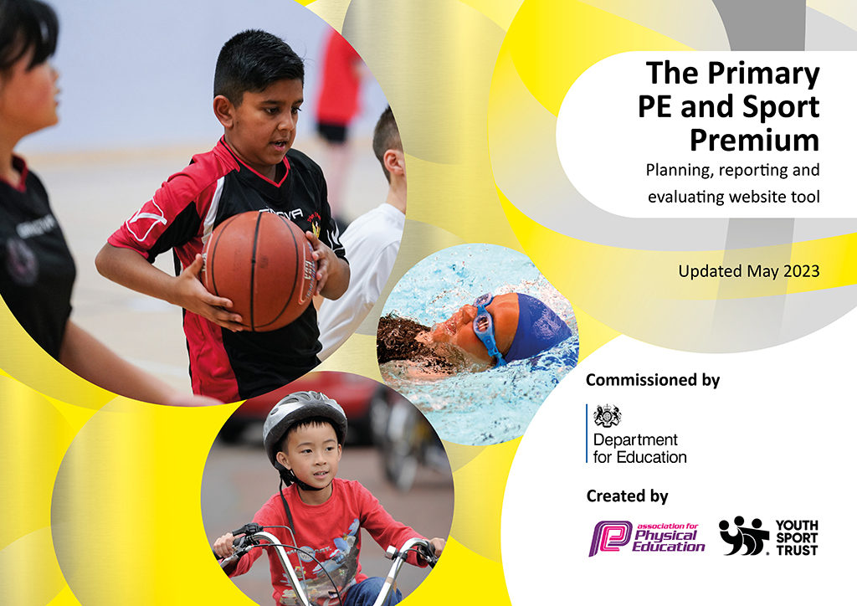
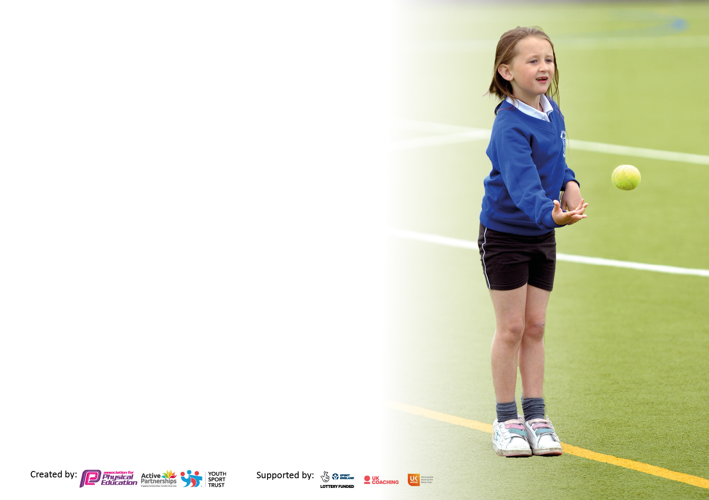

It is important that your grant is used effectively and based on school need. The Education Inspection Framework makes clear there will be a focus on ‘whether leaders and those responsible for governors all understand their respective roles and perform these in a way that enhances the effectiveness of the school’.

Under the Quality of Education Ofsted inspectors consider:
Intent - Curriculum design, coverage and appropriateness
Implementation - Curriculum delivery, Teaching (pedagogy) and Assessment
Impact - Attainment and progress

To assist schools with common transferable language this template has been developed to utilise the same three headings which should make your plans easily transferable between working documents.

Schools must use the funding to make additional and sustainable improvements to the quality of Physical Education, School Sport and Physical Activity (PESSPA) they offer. This means that you should use the Primary PE and sport premium to:

- Develop or add to the PESSPA activities that your school already offer
- Build capacity and capability within the school to ensure that improvements made now will benefit pupils joining the school in future years
- The Primary PE and sport premium should not be used to fund capital spend projects; the school’s budget should fund these.

Pleasevisitgov.ukfortherevisedDfEguidanceincludingthe5keyindicatorsacrosswhichschoolsshoulddemonstrate animprovement.Thisdocumentwillhelpyoutoreviewyourprovisionandtoreportyourspend.DfEencouragesschools to use this template as an effective way of meeting the reporting requirements of the Primary PE and Sport Premium.

We recommend you start by reflecting on the impact of current provision and reviewing the previous spend.

Schools are required to publish details of how they spend this funding, including any under-spend from 2021/2022, as well as on the impact it has on pupils’ PE and sport participation and attainment. All funding must be spent by 31st July 2024.

We recommend regularly updating the table and publishing it on your website throughout the year. This evidences your ongoing self-evaluation of how you are using the funding to secure maximum, sustainable impact. Final copy must be posted on your website by the end of the academic year and no later than the 31st July 2024. To see an example of how to complete the table please click HERE.

Details with regard to funding
Please complete the table below.

Total amount carried over from 2022/23 | £ 27,721.
Total amount allocated for 2022/23 | £ 17,680.
How much (if any) do you intend to carry over from this total fund into 2023/24? | £ 5504.
Total amount allocated for 2023/24 | £ 17,680
Total amount of funding for 2023/24. To be spent and reported on by July 2024. | £ 23,184.
Swimming Data
Please report on your Swimming Data below.

Meeting national curriculum requirements for swimming and water safety.

N.B. Complete this section to your best ability. For example you might have practised safe self-rescue techniques on dry land which you can then transfer to the pool when school swimming restarts.
Due to exceptional circumstances priority should be given to ensuring that pupils can perform safe self-rescue even if they do not fully meet the first two requirements of the NC programme of study
What percentage of your current Year 6 cohort swim competently, confidently and proficiently over a distance of at least 25 metres?  N.B. Even though your pupils may swim in another year please report on their attainment on leaving primary school at the end of the summer term 2023.  Please see note above | 86%
What percentage of your current Year 6 cohort use a range of strokes effectively [for example, front crawl, backstroke and breaststroke]?  Please see note above | 80%
What percentage of your current Year 6 cohort perform safe self-rescue in different water-based situations? | 89%
Schools can choose to use the Primary PE and sport premium to provide additional provision for swimming but this must be for activity over and above the national curriculum requirements. Have you used it in this way? | Yes/No

Action Plan and Budget Tracking
Capture your intended annual spend against the 5 key indicators. Clarify the success criteria and evidence of impact that you intend to measure to evaluate for pupils today and for the future.

Academic Year: 2023/24 | Total fund allocated: £23,184 | Date Updated: 25.7.24
Key indicator 1: The engagement of all pupils in regular physical activity – Chief Medical Officers guidelines recommend that primary school pupils undertake at least 30 minutes of physical activity a day in school |  |  |  | £7237.98  Percentage of total allocation:
 |  |  |  | 31%
Intent | Implementation |  | Impact
Your school focus should be clear what you want the pupils to know and be able to do and about  what they need to learn and to consolidate through practice: | Make sure your actions to achieve are linked to your intentions: | Funding allocated: | Evidence of impact: what do pupils now know and what can they now do? What has changed?
- Raise activity during the lunch time play.  - Increase children’s awareness of a range of physical activity and sport (beyond football). | - Sports Coach to run a timetabled activity during lunch hour covering a range of ‘traditional’ sports and new sports e.g. cheerleading.  - Purchase play equipment including new goals. | - £6669  - £568.98 | - Children will be more physically active and have had an opportunity to try out a range of sports. | It is important for children to get enjoyment from physical activity as this will encourage them to remain physically active as they grow up. Positive experiences also support this.  Pupils express enjoyment of lunchtime activities, highlighting their variety and connection to PE skills, with many indicating that these activities are popular among the majority of the school.
Key indicator 2: The profile of PESSPA being raised across the school as a tool for whole school improvement |  |  |  | £1816.84  Percentage of total allocation:
 |  |  |  | 8%
Intent | Implementation |  | Impact
Your school focus should be clear what you want the pupils to know and be able to do and about  what they need to learn and to consolidate through practice: | Make sure your actions to achieve are linked to your intentions: | Funding allocated: | Evidence of impact: what do pupils now know and what can they now do? What has changed?
- Increase activity and inclusive play for ALL children (including the least active). | - Purchase of additional resources | 1. £1816.84 | - All children (including the least active) will be more active during playtime.  - Negative behavior during playtime will decrease.  - Skills learnt during playtimes will benefit classroom behavior e.g. team work, creativity. | This is a change of culture to the school putting playtimes as an important part of the school day. Increase in positive behavior in the classroom and outside.  Pupils have indicated their enjoyment in using equipment during break times, with most spending this time actively moving around and engaging in play.

Key indicator 3: Increased confidence, knowledge and skills of all staff in teaching PE and sport |  |  |  | £7715  Percentage of total allocation:
 |  |  |  | 33%
Intent | Implementation |  | Impact
Your school focus should be clear what you want the pupils to know and be able to do and about  what they need to learn and to consolidate through practice: | Make sure your actions to achieve are linked to your intentions: | Funding allocated: | Evidence of impact: what do pupils now know and what can they now do? What has changed?
- To develop the inclusive teaching skills of teachers. | - Additional Active Trowbridge coach to ensure all children are accessing the PE curriculum and share inclusive practice with teachers. | - £7220 | - Children will have teaching from more skilled and confident teachers. | Teachers have noted that clear instructions on pupils' needs, alongside coach involvement, have enhanced participation. Coaches effectively manage less engaged learners, and varied teaching methods have improved engagement in PE lessons, benefiting overall learning outcomes.
- To purchase GetSet4PE scheme enabling all staff to confidently teach PE lessons. | - Scheme allows teachers to steadily and confidently teach a range of skills across different physical activities with confidence. | - £495 | - Children will have access to a consistent, high quality teaching scheme with a progression of skills throughout their primary schooling. | Teachers feel confident in delivering lessons and achieving required outcomes. The broad curriculum offers a variety of sports and physical activities. While skill progression is evident, some elements in EYFS can feel disjointed.
Key indicator 4: Broader experience of a range of sports and activities offered to all pupils |  |  |  | £6214.18  Percentage of total allocation:
 |  |  |  | 27%
Intent | Implementation |  | Impact
Your school focus should be clear what you want the pupils to know and be able to do and about  what they need to learn and to consolidate through practice: | Make sure your actions to achieve are linked to your intentions: | Funding allocated: | Evidence of impact: what do pupils now know and what can they now do? What has changed?
- To set up forest school.  - Forest school training.  - To supply afterschool sports clubs. | - Purchase of forest school equipment.  - Forest school training.  - Active Trowbridge coach to run sports club after school available to all children. | - £1217.28  - £2,374.90  - £2622 | - Children have further support to development a lifelong relationship between the learner and the natural world.  - Children have access to a wider range of sports and activities. | Teachers report that the benefits of forest school are evident, as less engaged pupils thrive outdoors, with practical and sensory learners flourishing through real-life examples and hands-on experiences.  A variety of clubs have been provided, covering different sports and activities. Some clubs are more popular than others, with varying participant numbers. Pupils involved in after-school clubs report that they enhance their skills during these sessions and apply them effectively in games and activities.

 | Key indicator 5: Increased participation in competitive sport |  |  |  |  | £200  Percentage of total allocation:
 |  |  |  |  |  | 1%
 | Intent | Implementation |  |  | Impact
 | Your school focus should be clear what you want the pupils to know and be able to do and about  what they need to learn and to consolidate through practice: | Make sure your actions to achieve are linked to your intentions: | Funding allocated: |  | Evidence of impact: what do pupils now know and what can they now do? What has changed?
- Most children (Y6) will attend at least one inter-school sport competition during the year. |  | - Sports Partnership  - Book and attend events. | - £200 | - Most children will have attended an event which will have given them the opportunity to represent their school. This will increase their positive relationship with school sport and/ or physical activity. |  | These experiences will support the children in finding enjoyment in school sport. The competitions are varied e.g. competitive, festivals so all children will find success.  Pupils spoke positively about the sports competitions they had been involved in. Not all pupils wanted/took part in an inter-school competition.
Total Spend: £23,184.

Signed off by
Head Teacher: | Kelandie Ash | Subject Leader: | Daniel Grech
Date: | 25.07.24 | Date: | 25.07.24
Governor: | Linda Morgan | Date: | 25.07.24

