Number rhymes, songs and activities

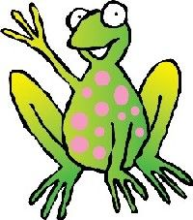


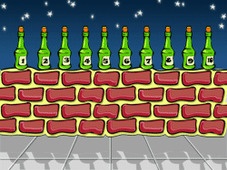



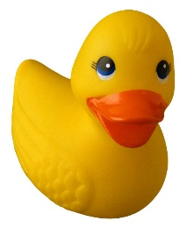

A selection of rhymes, songs and game ideas for you to enjoy at home with your child.
There are many websites which share the words and tunes to many well-known rhymes and songs.
Two such examples are:
http://www.nurseryrhymes4u.com/NURSERY_RHYMES/ALPHABETICAL.html
http://www.bbc.co.uk/cbeebies/tweenies/songtime/songs/
Have fun!
If you have any other ideas to share, we would love to hear them.

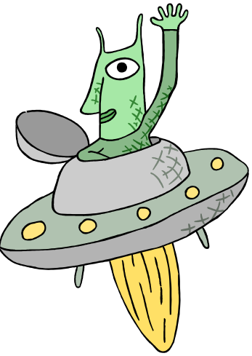
Five little men in a Flying Saucer.
Five little men in a flying saucer,
Flew round the world one day.
They looked left and right,
But they didn't like the sight.
So one man flew away..........................Whoosh!
Then:
four little men.
three little men.
two little men.
one little man.
Music available to listen to at http://www.nurseryrhymes4u.com/NURSERY_RHYMES/Page_31.html

Five Currant Buns in a Bakers Shop.
Five currant buns in the baker's shop,
Big and round with a cherry on the top.
Along came (insert child’s name) with a penny one day,
Bought a currant bun and took it away……
………….Then four, three, two, one current buns

No currant buns in the baker's shop,
Nothing big and round with a cherry on the top.
Along came (insert child’s name) with a penny one day,
"Sorry" said the baker, "no more currant buns today."
Music available to listen to at http://www.nurseryrhymes4u.com/NURSERY_RHYMES/Page_45.html
Five little Ducks.
Five little ducks went swimming one day,
Over the pond and far away.
Mummy duck said "Quack, quack, quack,quack.
But only four little ducks came swimming back.

then:
Four little ducks,
Three little ducks,
Two little ducks,
One little duck.
No little ducks went swimming one day,
Over the pond and far away.
Mummy duck said "Quack, quack, quack, quack"
And all the little ducks came back.
Music available to listen to at
http://www.nurseryrhymes4u.com/NURSERY_RHYMES/Page_21.html
Five Little Monkeys (spoken)

Five little monkeys jumping on the bed,
One fell off and bumped his head.
Mum called the doctor and the doctor said,
"No more monkeys jumping on the bed!"
Then: four, three, two…….
One little monkey jumping on the bed,
He fell off and bumped his head.
Mum called the doctor and the doctor said,
"Put those monkeys straight to bed!
Five Little Firemen.
Five little Firemen standing in a row,
1, 2, 3, 4, 5, they go.
Hop on the engine with a shout,
Quicker than a wink the fire is out.

Four little Firemen standing in a row,
1, 2, 3, 4, (nod head silently here), they go.
Hop on the engine with a shout,
Quicker than a wink the fire is out.
Three little Firemen standing in a row,
1, 2, 3, (nod head twice silently here) they go.
Hop on the engine with a shout,
Quicker than a wink the fire is out.
Two little Firemen standing in a row,
1, 2, (nod head three times silently here) they go.
Up in the engine with a shout,
Quicker than a wink the fire is out.
One little Fireman standing on his own.
1, (nod head four times silently here) he goes.
Hop on the engine with a shout.
Quicker than a wink the fire is out.

Five little speckled Frogs.

Five little speckled frogs,
Sat on a speckled log.
Eating the most delicious bugs,
Yum, yum.
One jumped into the pool,
Where it was nice and cool.
Now there are four green speckled frogs,
Glub, glub.
then:
four little speckled frogs.
three little speckled frogs.
two little speckled frogs.
one little speckled frog.
Music available to listen to at
http://www.nurseryrhymes4u.com/NURSERY_RHYMES/Page_53.html

One, Two, Three, Four, Five.
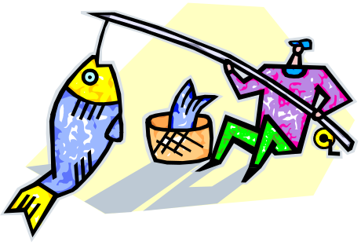
One, two, three, four, five,
Once l caught a fish alive.
Six, seven, eight, nine, ten,
Then l let it go again;
"Why did you let it go?"
"Because it bit my finger so."
"Which finger did it bite?"
This little finger on my right.
Music available to listen to at http://www.nurseryrhymes4u.com/NURSERY_RHYMES/Page_22.html
The Ants go Marching.
The ants go marching one by one, hurrah, hurrah,
The ants go marching one by one, hurrah, hurrah,
The ants go marching one by one,
The little one stops to suck his thumb
And they all go marching down to the ground
To get out of the rain, BOOM! BOOM! BOOM!
The ants go marching two by two, hurrah, hurrah,
The ants go marching two by two, hurrah, hurrah,
The ants go marching two by two,
The little one stops to tie his shoe
And they all go marching down to the ground
To get out of the rain, BOOM! BOOM! BOOM!
The ants go marching three by three, hurrah, hurrah,
The ants go marching three by three, hurrah, hurrah,
The ants go marching three by three,
The little one stops to climb a tree
And they all go marching down to the ground
To get out of the rain, BOOM! BOOM! BOOM!
The ants go marching four by four, hurrah, hurrah,
The ants go marching four by four, hurrah, hurrah,
The ants go marching four by four,
The little one stops to shut the door
And they all go marching down to the ground
To get out of the rain, BOOM! BOOM! BOOM!
The ants go marching five by five, hurrah, hurrah,
The ants go marching five by five, hurrah, hurrah,
The ants go marching five by five,
The little one stops to take a dive
And they all go marching down to the ground
To get out of the rain, BOOM! BOOM! BOOM!

The ants go marching six by six, hurrah, hurrah,
The ants go marching six by six, hurrah, hurrah,
The ants go marching six by six,
The little one stops to pick up sticks
And they all go marching down to the ground
To get out of the rain, BOOM! BOOM! BOOM!
The ants go marching seven by seven, hurrah, hurrah,
The ants go marching seven by seven, hurrah, hurrah,
The ants go marching seven by seven,
The little one stops to pray to heaven
And they all go marching down to the ground
To get out of the rain, BOOM! BOOM! BOOM!
The ants go marching eight by eight, hurrah, hurrah,
The ants go marching eight by eight, hurrah, hurrah,
The ants go marching eight by eight,
The little one stops to shut the gate
And they all go marching down to the ground
To get out of the rain, BOOM! BOOM! BOOM!
The ants go marching nine by nine, hurrah, hurrah,
The ants go marching nine by nine, hurrah, hurrah,
The ants go marching nine by nine,
The little one stops to check the time
And they all go marching down to the ground
To get out of the rain, BOOM! BOOM! BOOM!

The ants go marching ten by ten, hurrah, hurrah,
The ants go marching ten by ten, hurrah, hurrah,
The ants go marching ten by ten,
The little one stops to say "The End"
And they all go marching down to the ground
To get out of the rain, BOOM! BOOM! BOOM!

One, Two, Buckle My Shoe. (spoken)
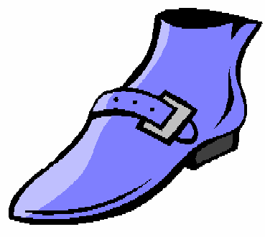
One, two, buckle my shoe;
Three, four, knock at the door;
Five, six, pick up sticks;
Seven, eight, lay them straight;
Nine, ten, a good fat Hen;
Eleven, twelve, dig and delve;
Thirteen, fourteen, maids a-courting;
Fifteen, sixteen, maids a-kissing;
Seventeen, eighteen, maids a-waiting;
Nineteen, twenty, my plate's empty;

One Potato.
One potato, two potato,
Three potato, four;
Five potato, six potato,
Seven potato more.


One Man Went to Mow.
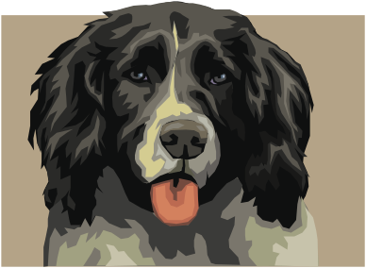
One man went to mow,
Went to mow a meadow,
One man and his dog,
Went to mow a meadow.
Two men went to mow,
Went to mow a meadow,
Two men, one man and his dog,
Went to mow a meadow.
Three men went to mow,
Went to mow a meadow,
Three men, two men, one man and his dog,
Went to mow a meadow.
Four men went to mow,
Went to mow a meadow,
Four men, three men, two men, one man and his dog,
Went to mow a meadow.

Music available to listen to at: http://www.nurseryrhymes4u.com/NURSERY_RHYMES/Page_881.html
http://www.bbc.co.uk/cbeebies/tweenies/songtime/songs/o/oneman.shtml

Five in a Bed
(Can be extended to ten in a bed)

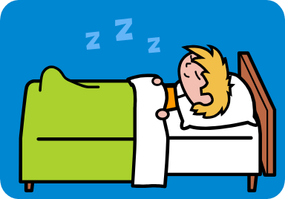
There were five in a bed and the little one said
Roll over, roll over
So they all rolled over
And one fell out
There were four in the bed and the little one said
Roll over, roll over
So they all rolled over
And one fell out
There were three in the bed and the little one said
Roll over, roll over
So they all rolled over
And one fell out
There were two in the bed and the little one said
Roll over, roll over
So they all rolled over
And one fell out
There was one in the bed and the little one said
Roll over, roll over
So they all rolled over
And he fell out
The were none in the bed and the bed went
Ping!
Just went!

Music available to listen to at: http://www.bbc.co.uk/cbeebies/tweenies/songtime/songs/f/fiveinabed.shtml

Five Fat Sausages

Five fat sausages sizzling in a pan;
All of a sudden one went BANG!

Four fat sausages …. Etc.

If your child is ready to count down in twos, try

Ten fat sausages sizzling in a pan
One went pop and the other went BANG!

Five green Bottles (extend to ten)
Five green bottles standing on the wall.
Five green bottles standing on the wall.
And if one green bottle should accidently fall,
there'll be four green bottles standing on the wall.
then:
Four green bottles
Three green bottles
Two green bottles
One green bottle
No green bottles

Music available to listen to at: http://www.nurseryrhymes4u.com/NURSERY_RHYMES/Page_54.html

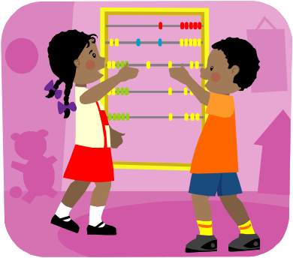
Activities to try at home

Listed below are a number of activities you may like to try at home with your child. The most important thing is to make maths and numbers fun and interesting for your child in any way that you can!

- Number Line Activities (0 – 20 number line and 0 – 10 number cards to peg out have been provided). The number line can be used in a number of ways spontaneously for example a child may be encouraged to find the number on the line which matches their age, number of bricks in their tower, number of grapes on their plate. It also provides a good model when writing numbers.
- Using the number line – use regularly to count forwards and backwards. As your child moves through the school they will be encouraged to use the number line to support them when adding and subtracting so it is important that they become familiar with it.
- Using the number cards
  - Ordering numbers – use the number cards to order them (maybe peg out on a washing line). Say the number names as you do so. When confident with the number order, you could move on to pegging out in reverse order.
  - Muddled numbers – Lay out the number cards in the wrong order – can your child correct you?
  - Missing numbers – lay the number cards out in order. Then ask your child to close their eyes while you take away some of the numbers (just one to begin with). Can your child work out which number is missing? Try counting up together from 1 to find the answer.
  - Guess the number – Lay out the numbers cards. Then secretly choose a number. Ask your child to ask questions to try and guess the number e.g. Is it bigger than 5?
  - Number Actions – Point to a number card. Give your child an action to do that many times e.g. jump 4 times.
  - Hide and find – hide the number cards in a room/outside – can your child find them and then put them in the correct order to check they have found all cards. You could also ask them to collect things for each number e.g. collect 4 blades of grass to place on card 4.
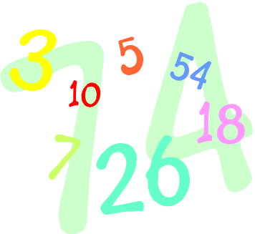
- Numbers all around! - When out and about encourage your child to find and identify numbers e.g. door numbers, number plates, birthday cards etc. You may like to start a scrapbook with photos of the numbers you have seen as well as cuttings from newspapers etc. which show numbers. The same activity can be done with shapes.
- Look for opportunities to count and talk about numbers during everyday activities such as laying the table, pairing socks, preparing and eating food etc.
- Playing simple board/card games/dominoes at home is a great way to enthuse children about maths. (For an example board game see snake ladder board at the end of this booklet.) After playing board games of your own, a great thing to do is to allow your child to design and make their own board game to play with you and/or friends.

……..And now some games to get you started!

Feel and Count
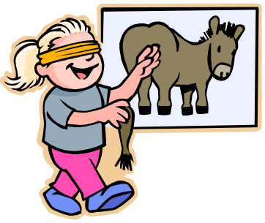
You will need:
- A collection of small items such as shells etc.
- A soft scarf/piece of material for a blindfold.

What to do
- Take turns to be blindfolded.
- One player chooses some objects and puts them in the hand of the person who is blind folded.
- The blind folded player counts the objects and says the number. If they are right, they score 1 point.
- Continue, taking turns to be blindfolded. After 5 turns each the player with the most points is the winner.

Give it Away!
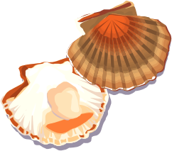
You will need:
- A collection of small things e.g. pasta, shells
- Dice

What to do
- Each player takes 10 items.
- The starting player rolls the dice, says the number on the dice and then gives that number of their items to the other player (or player on their left if there are more than 2 players).
- Continue taking turns until one player has given away all of their items (or you could also play until one player has 20 items).

Other ways to play:
- Play the game with a bowl of water, giving away the right number of spoonfuls each time until one bowl is empty.
Parking Spaces

You will need:

- A cardboard box
- Scissors
- Felt tip pen
- A small car for each player
- Chalk
- Paper and pen

What to do
- Cut the top and bottom off the cardboard box and then cut some arches in one side. Make as many arches as you like. Adult supervision will be needed for this.
- Decorate the box and write numbers over the arches.
- Chalk a starting line on the ground or lay something to mark a starting line.
- Players take it in turns to roll the car towards the arches.
- If your car goes into an arch you score the number written above. Keep going for a number of turns, the winner is the person with the highest score.
What a Good Guess!
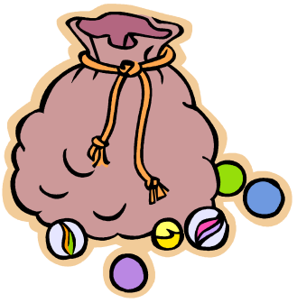
You will need:
- A small box
- Small items to put in the box e.g. pasta, buttons, marbles etc.
- A bowl for each player

What to do
- The first player takes a handful of objects and puts them on the table. They guess how many they have taken, then count. If they are right they put items in own bowl, if not they put them back in the box.
- Continue for a few turns each.
- The player with the most things in their own bowl wins.

*It is a good idea to play this with fairly large items to start with.

Cup Challenge

You will need:

- Yoghurt pots of small cups
- Small items such as pasta, dried beans etc.

What to do
- Count some items into the cup.
- Explain that you are going to take away (or put in) …… more. It is a good idea to start with taking away/adding one thing to begin with.
- Turn the cup upside down.
- Ask your child to show you with their fingers the number of things they think are under the cup now.
- As the children become familiar with the game, they can take a turn with the cup and be game leader.

One a penny…..

You will need:
- A collection of 1p coins
- Smaller numbers of 2p, 5p and 10p coins
- Dice

What to do
- Take turns to throw the dice and take that number of 1p coins.
- Repeat 3 times, the winner is the person with the most coins at the end.

Other ways to play:
Play as described above but at the end each player must exchange their 1p coins for 2p or 5p or 10p coins.

Number Snap

You will need:
- Number cards 0 – 9 (made from pieces of paper)
- Crayons
- A numbered board drawn on a piece of paper
0 | 1 | 2 | 3 | 4
5 | 6 | 7 | 8 | 9

What to do
- Cut a piece of paper into 20 pieces and write the numbers 0 – 9 on the pieces. You will have enough for 2 of each.
- Mix up the number cards and put them in a pile, face down.
- Every player needs their own playing board and a crayon.
- Players take it in turns to take a number card, saying the number as they reveal it. They then find the number on their number board and colour it in.
- If you reveal a number you have already coloured, you miss a turn.
- Continue until one player has coloured all their numbers.

Climb the Ladder!
Each player puts a counter on number 0. Take turns to roll the dice. Move that number of spaces on the ladder. The first player to 20 wins. To practice counting back, start the game at 20.
