North Bradley CE Primary School – Calculation Policy
‘Shine as a light in the world’ (Philippians 2:15)
‘SHINE’
Strive, Hope, Inclusion, Nurture, Equality.

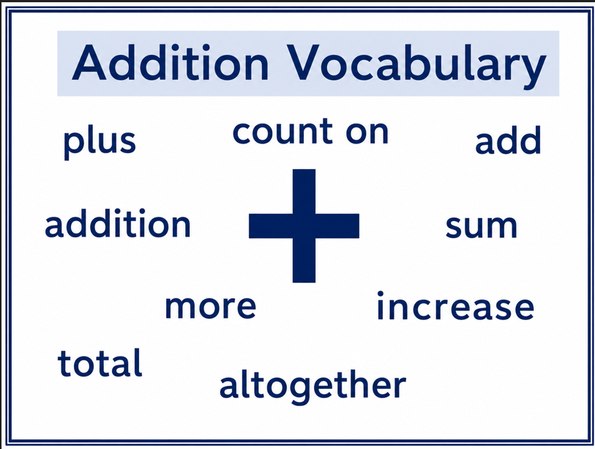
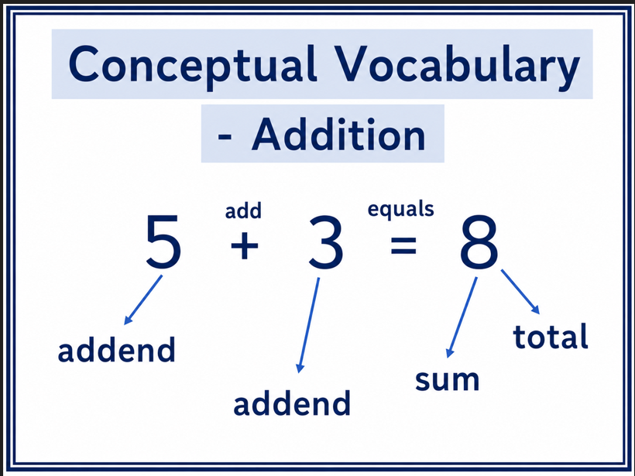

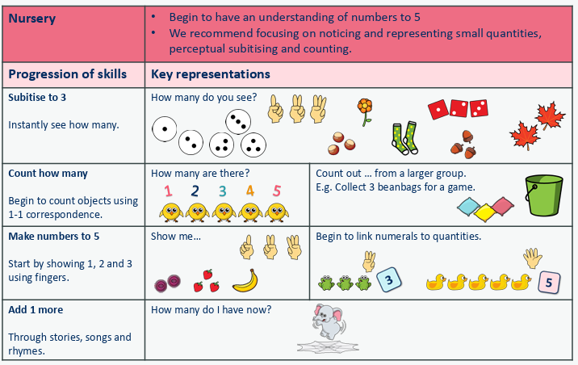

Addition - EYFS
Stage | Concrete | Pictorial | Abstract
1 | Counting on to find one more.  Children add one more person or object to a  group to find one more.  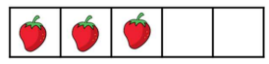  Can you show me 1 more?  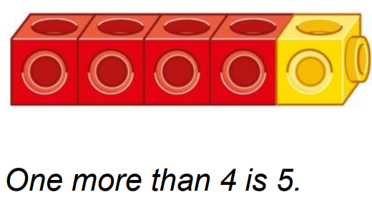 | Use number tracks and number lines to understand how to link counting on with finding one more.  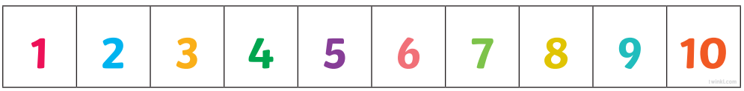  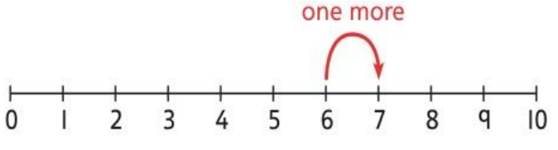  One more than 6 is 7.  7 is one more than 6. | Children verbally count beyond 20 in 1s. They form numbers to 10.  Children fill in the blanks using their number formation:  ____ is 1 more than ____  1 more than ____ is ____
2 | Part-part-whole relationships within 10 (bonds).  Break apart a group and put back together  to find and form number bonds. Children use a range of concrete resources (e.g., double sided counters) to explore number bonds. Use five and ten frames to represent key  number bonds.  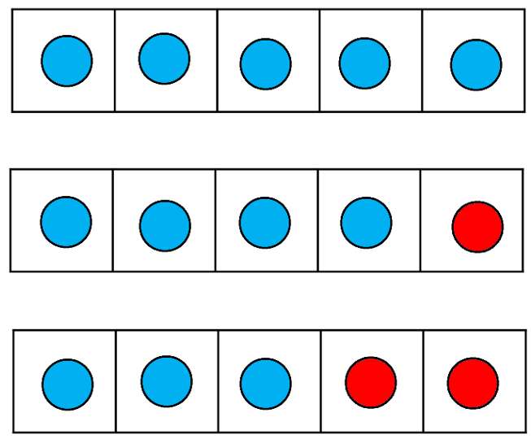 | Children draw part-part-whole models to support them with understanding the different relationships within the whole.  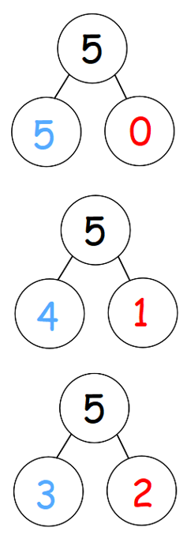 | Children begin to record number bonds using the addition symbol.  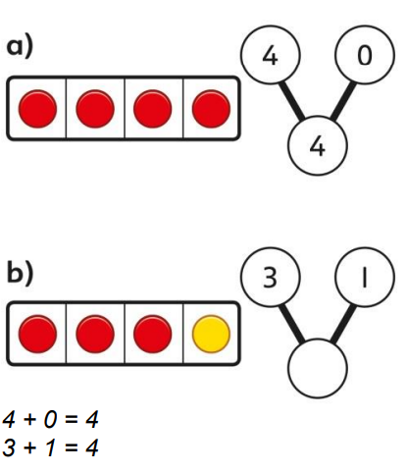
Addition - KS1
Stage | Concrete | Pictorial | Abstract
3 | Adding groups of objects.  Children will use a range of resources to add groups of objects together. Calculations are also represented using part-whole models.  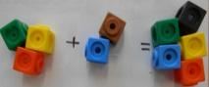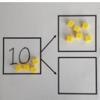  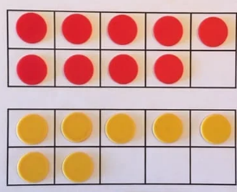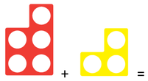 | Children use jottings to represent the resources they are use. Children also show addition using part-whole bar models.  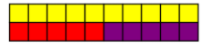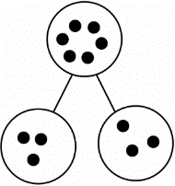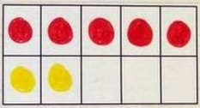 | 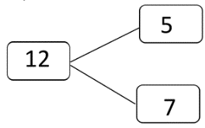  Children will record their calculation using a pictorial method along with a calculation using numbers and symbols.  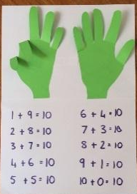  5 + 4 = 9  They may use their fingers to support their mental methods.
4 | Children will use a range of resources to support their calculations, starting with the larger number and counting on in ones.  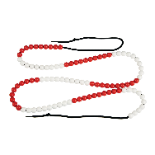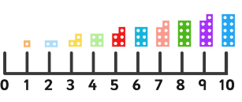 | Using a number line to count on in ones.  Start at the larger number on the number line and count on in ones or in one jump to find the answer. Children will show their representations from the concrete method using pictures.  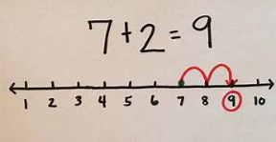  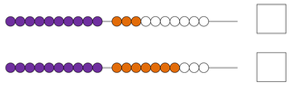 | Children will record their calculation using a pictorial method along with a calculation using numbers and symbols.
5 | Bridging 10.  Children will use a range of resources to support their understanding of bridging 10 -starting with the larger number and partition the smaller number to make 10. 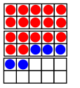  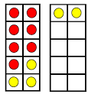  This can then be applied to bridging multiples of 10.  17 + 5 = 22 | Using a picture or a number, children regroup or partition the smaller number using the part-whole model to make 10.  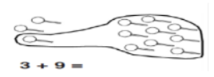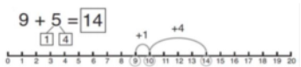  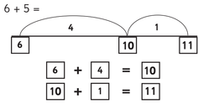  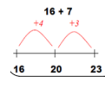 | 7 + 4 = 7 + 3 + 1 = 11  If I'm at 7, how many more do I need to make 10? How many do I have left to add to 10?  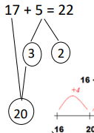  17 + 5 =  17 + 3 + 2 =
6/7 | Stage 6: Partitioning  To begin with, children will use dienes cubes and their knowledge of place value to add larger numbers where regrouping is not required.  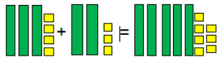  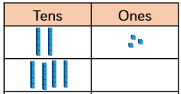  They will then progress onto add larger numbers where they will need to partition, regroup, and recombine. Models include dienes, place value counters and Numicon.  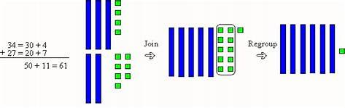  Children will also be encouraged to start to line up the digits vertically.  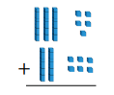 | 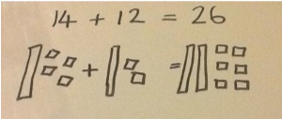  Children will represent the dienes using drawing, combining tens and ones to calculate the answer.  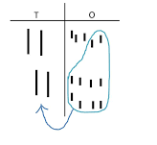  Stage 7: Jumping forwards on a number line.  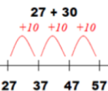  Numbers will get progressively larger throughout the key stage. Children will be able to add tens and ones using an empty number line.  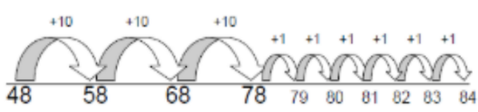  When they’re confident they’ll be able to count in multiples of 10s and 1s:  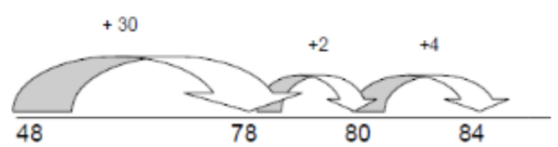 | 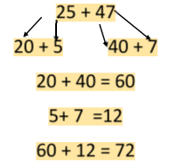  Children will begin to use the partitioning method. Tens and ones will be added to form partial sums and then these partial sums will be added together to find the total.
Addition – LKS2
Stage | Concrete | Pictorial | Abstract
8 | Bridging multiples of 10.  Children will use their knowledge of number bonds to 10 to bridge through multiples of 10 over 100. They will also apply their understanding to bridge multiples of 100 and 1000. Dienes and place value counters will be used to support the children with partitioning and regrouping.  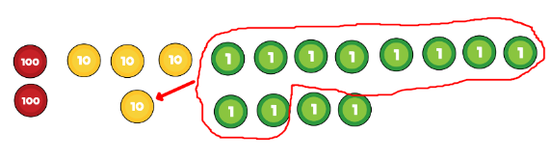  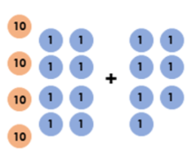 | Children will use number lines to support them with bridging through multiples of 10, 100 and 1000.  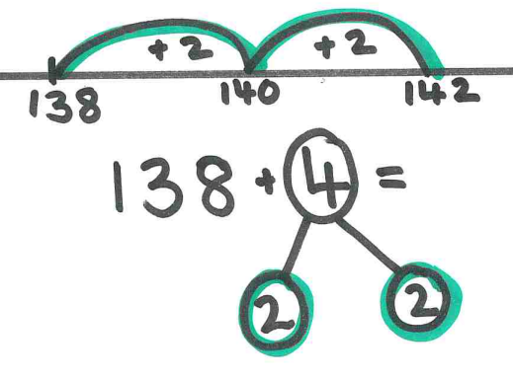  142 | 456 + 8 = 456 + 4 + 4  1,698 + 7 = 1,698 + 2 + 5  7,400 + 700 = 7,400 + 600 + 100
9/10 | Stage 9: Partitioning  To begin with, children will use dienes cubes and their knowledge of place value to add larger numbers where regrouping is not required.  1,222 + 1,123 =  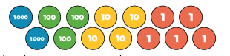  They will then progress onto regrouping using dienes and place value counters.  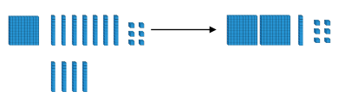 | Children to use the part-whole model alongside concrete resources to help them to work out missing values.  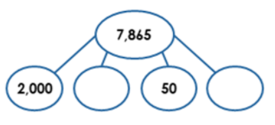  Stage 10: Jumping forwards on a number line.  Numbers will get progressively larger throughout the key stage. Children will be able to add hundreds, tens and ones using an empty number line and their knowledge of partitioning.  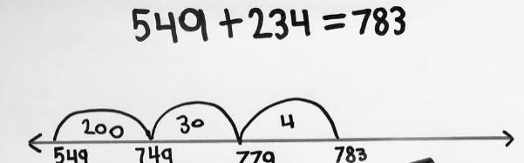 | Children to use jottings to partition numbers in order to add them.  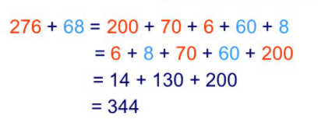  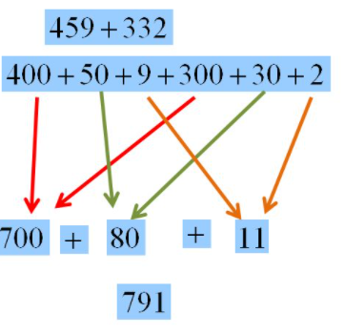
11 | Column addition – no exchange  The focus now moves to formal written addition. Children should be confident at placing numbers into a place value chart before attempting to add and subtract numbers using the written method. Base 10 and place value counters are used in a place value chart alongside the written method. No exchanges take place in this step, but it is a good idea to ask, “Do you have enough ones/tens to exchange for a ten/hundred?” as this will support their learning in future steps.  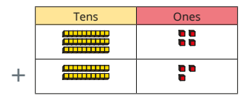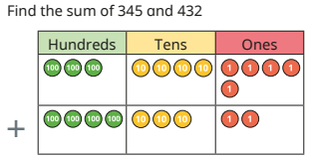  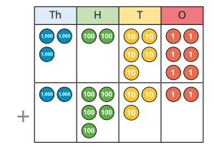 |  | 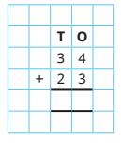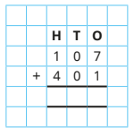  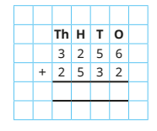
12 | Column addition – exchange  Children will add larger numbers where they will need to exchange place value counters or dienes.  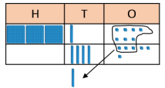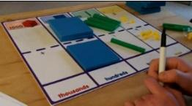 | 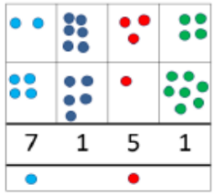  Children can draw a representation of the grid using larger numbers. | 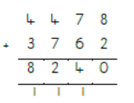  Column method for addition to be used.

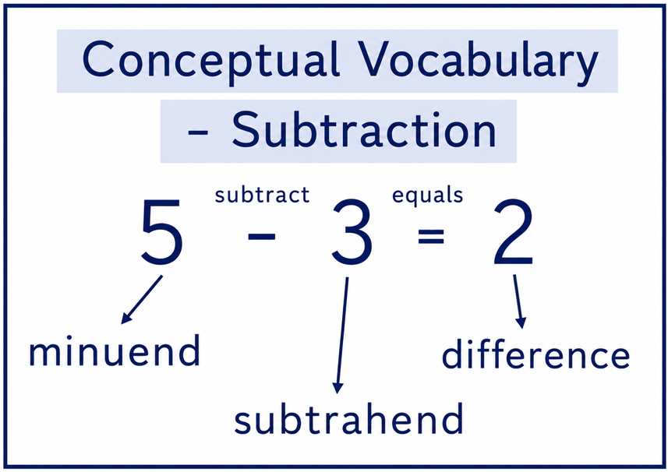
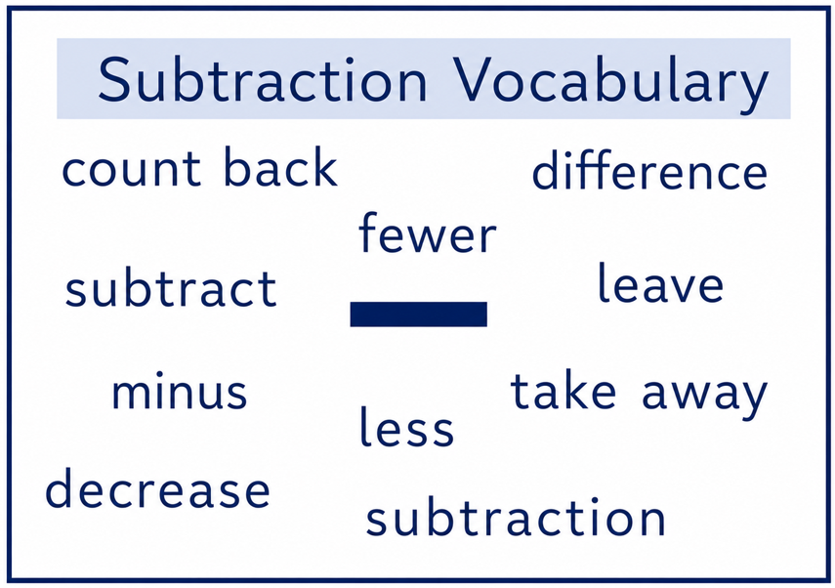

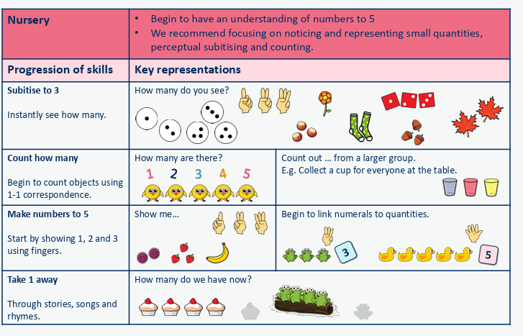

Subtraction - EYFS
Stage | Concrete | Pictorial | Abstract
1 | Counting back to find one less.  Children remove objects to find one less. 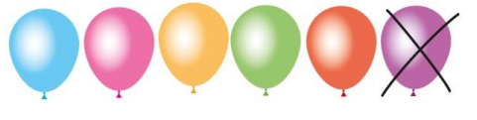  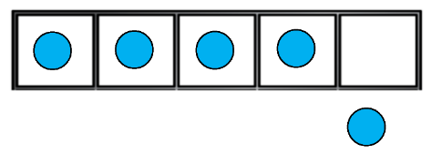 | Children draw and cross out or use counters to represent objects from a problem.  Use number tracks and number lines to understand how to link counting back with finding one less.  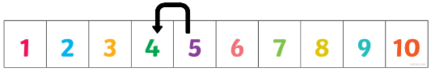 | Children fill in the blanks using their number formation:  One less than ___ is ___.  ___ is one less than ___
2 | Subtraction within 10.  Children to remove objects to show taking away.  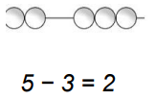  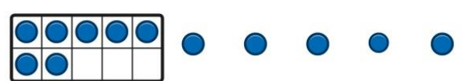 | Children draw and cross out or use counters to represent objects from a problem.  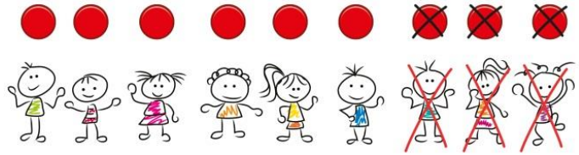 | Children begin to record number bonds using the subtraction symbol.

Subtraction - KS1
Stage | Concrete | Pictorial | Abstract
3 | Subtracting using objects (how many left...?)  Use a range of manipulatives and representations (including part whole model, cubes and bead strings) to subtract two numbers together by moving objects away from the group.  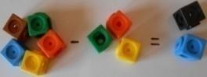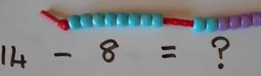  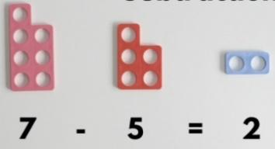 | Use jottings to represent numbers. Children will learn to cross out drawn objects to show what has been taken away.  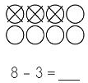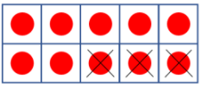 | Children will record their calculation using a pictorial method along with a calculation using numbers and symbols.  12 - 5 = 7  They may use their fingers to support their mental methods. 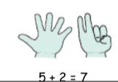
4 | Counting back in ones on a number line.  Children to count back to subtract. Bead strings are a useful resource to support children with this. It is vital to model how to count backwards by ‘putting the largest number in my head and counting backwards’.  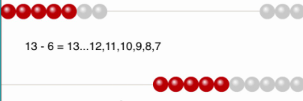 | Children will begin to draw their own number lines. Start at the larger number on the number line and count back in ones or in one jump to find the answer.  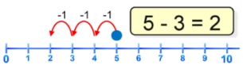  Numbers will get progressively larger throughout the key stage. Children will be able to subtract tens and ones using an empty number line. | Children will record their calculation using a pictorial method along with a calculation using numbers and symbols.
5 | Counting back on a number line by partitioning.
6/7 | Subtract using partitioning.  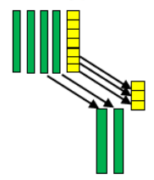  Children will use dienes cubes to subtract larger numbers where exchanging is not required. Children will lay out the first number using the dienes cubes and then move the second number away to show the subtraction.  Children will begin to use place value counters and dienes cubes to show how to exchange between tens and ones. They will be able to change 1 ten and exchange it for 10 ones. | Jumping back on a number line.  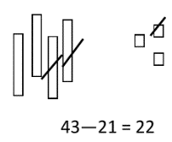  Children will show their representations from the concrete method using pictures.  Children will also draw dienes, demonstrating exchanging 1 ten for 10 ones and crossing out the smaller number. 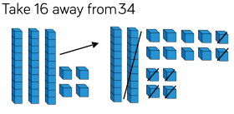 | Children will record their calculation using a pictorial method along with a calculation using numbers and symbols: 25 - 12 = 13  Children will begin to subtract multiples of tens: 25 - 10 = 15  Children will begin to use the partitioning method. Tens and ones will be subtracted separately. Prior methods such as ‘making 10’ and ‘counting back’ may be used to help children with crossing the tens boundary.  42 – 25 = 24  42 – 20 = 22  22 – 5 = 17  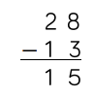  Children to begin to line up place value columns vertically.  Children to begin to line up place value columns vertically.
6/7 | Stage 6: Partitioning  To begin with, children will use dienes cubes and their knowledge of place value to add larger numbers where regrouping is not required.  They will then progress onto add larger numbers where they will need to partition, regroup, and recombine. Models include dienes, place value counters and Numicon.  Children will also be encouraged to start to line up the digits vertically. | Children will represent the dienes using drawing, combining tens and ones to calculate the answer.  Stage 7: Jumping forwards on a number line.  Numbers will get progressively larger throughout the key stage. Children will be able to add tens and ones using an empty number line.  When they’re confident they’ll be able to count in multiples of 10s and 1s: | Children will begin to use the partitioning method. Tens and ones will be added to form partial sums and then these partial sums will be added together to find the total.
Subtraction – LKS2
Stage | Concrete | Pictorial | Abstract
8 | Jumping back on a number line (100s, 10s and 1s)  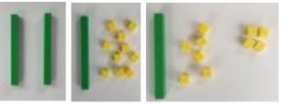  Children consolidate and use place value counters and dienes cubes to show how to exchange between units of number. They will be able to change 1 ten and exchange it for 10 ones.  They will begin to lay this out like the column method and removing counters or cubes away to represent taking away.  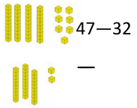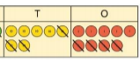 | 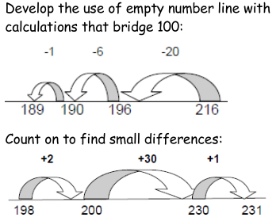  Consolidate their learning from KS1 by using an empty number line to calculate larger numbers.  Children will also be able to draw representations of dienes cubes and place value counters by crossing out the number being taken away.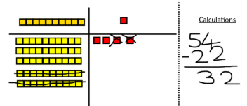 | 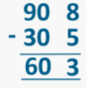  Children to further secure their knowledge using the partitioning method but will start to lay their work out using the column method approach. Tens and ones will be subtracted separately and then these numbers will be added together to find the total.  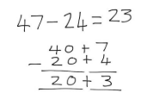
9 | Column subtraction – no exchange  Children subtract up to a 4-digit number from a 4-digit number with no exchanges, using concrete resources as well as the formal written method. Even though there is no exchanging, children should subtract from the smallest value column first. Before subtracting each column, ask, “Do you have enough ones/tens/hundreds to subtract ? ” If not, an exchange is needed.  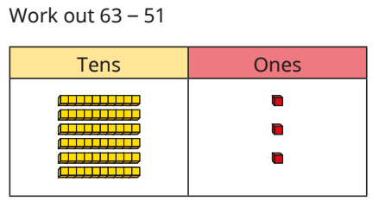  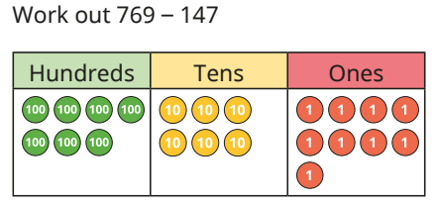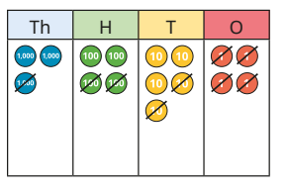 |  | 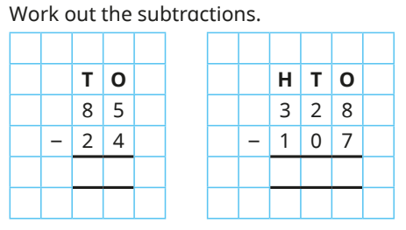  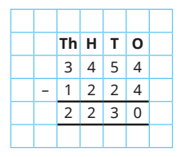
10 | Column subtraction – exchange  They use base 10 alongside the written calculation, but for subtraction they only need to make the number being subtracted from. For each calculation, prompt children to think about whether they need to make an exchange or not, and why. It is important that children complete the formal written method alongside any concrete manipulatives to support understanding.  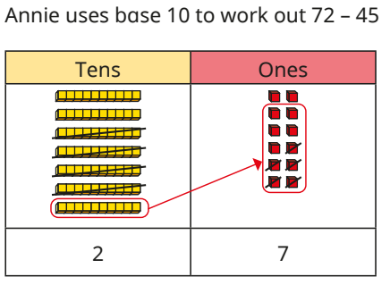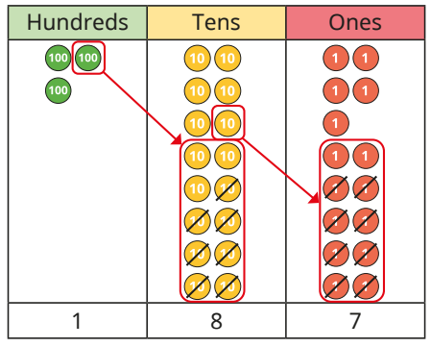  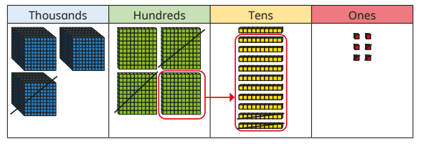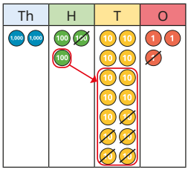 |  | 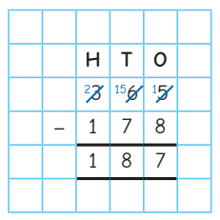  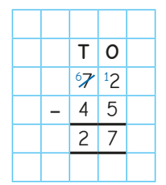  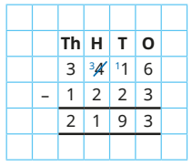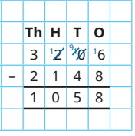
Subtraction – UKS2
Stage | Concrete | Pictorial | Abstract
13 | Column subtraction – with larger numbers  Children to continue to use place value counters and dienes to support their calculations. Children to apply prior methods to add larger numbers.  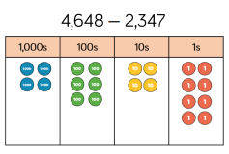  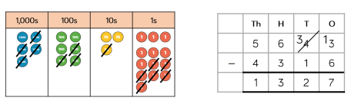 | Children draw representations from concrete activities using dienes cubes and place value counters.  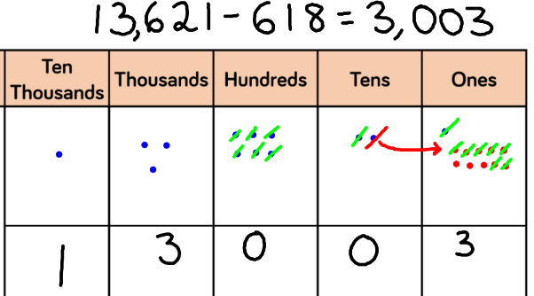 | Column subtraction – formal method (larger numbers)  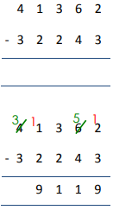  Children will continue to develop their understanding of column method subtraction. Calculations will become larger.
14 | Column subtraction - decimals  Children to continue to use place value counters and dienes to support their calculations. | Children can draw using place value counters showing how exchanging takes place between the units of numbers. Children will draw their representations showing where they have exchanged.  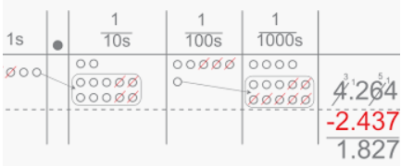 | Children will continue to develop their understanding of column method subtraction. Calculations will include decimal places and require 0 to be added as a placeholder.  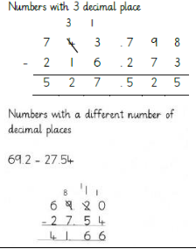
14 | 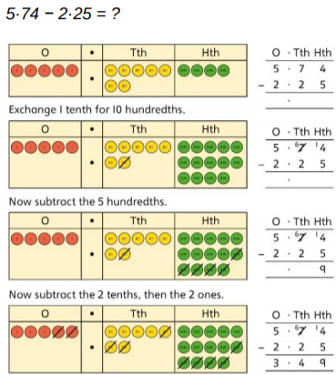  Children to apply prior methods decimal numbers.

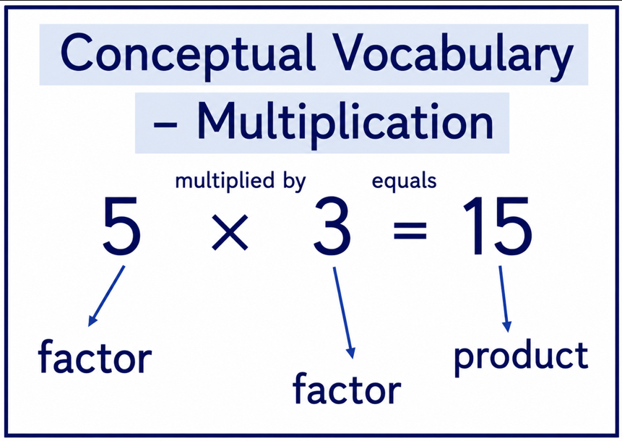
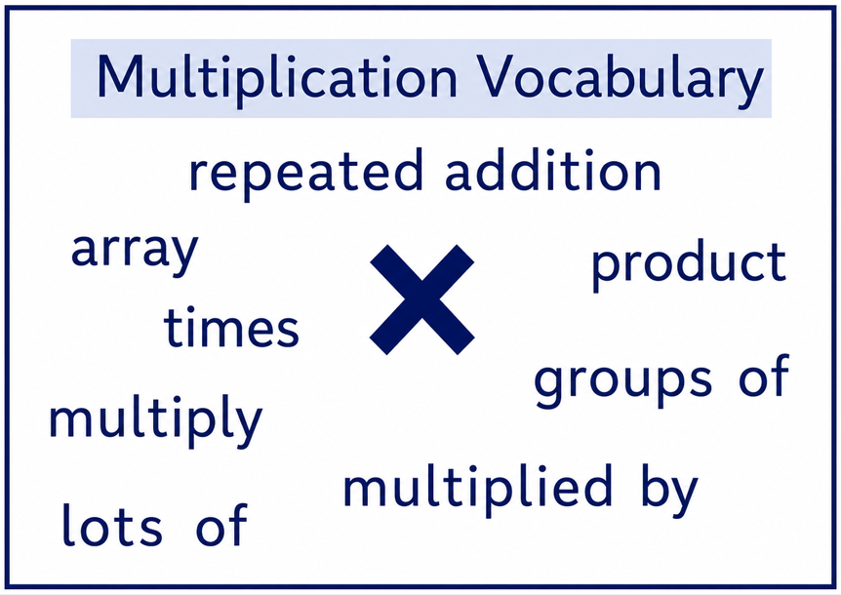

Multiplication - EYFS
Stage | Concrete | Pictorial | Abstract
1 | Doubling  The children will learn that double means ‘twice as many’. They should be given opportunities to build doubles using real objects and mathematical equipment. Building numbers using the pairwise patterns on 10 frames helps the children to see the doubles. Provide sets of dominoes and ask the children to find the doubles. Show the children how to play dominoes and look at the doubles they make as they play. Children to draw and represent doubles in a range of contexts.  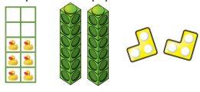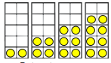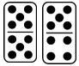 | 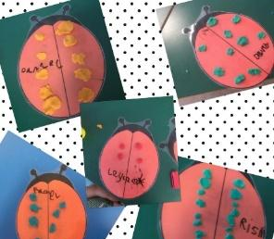  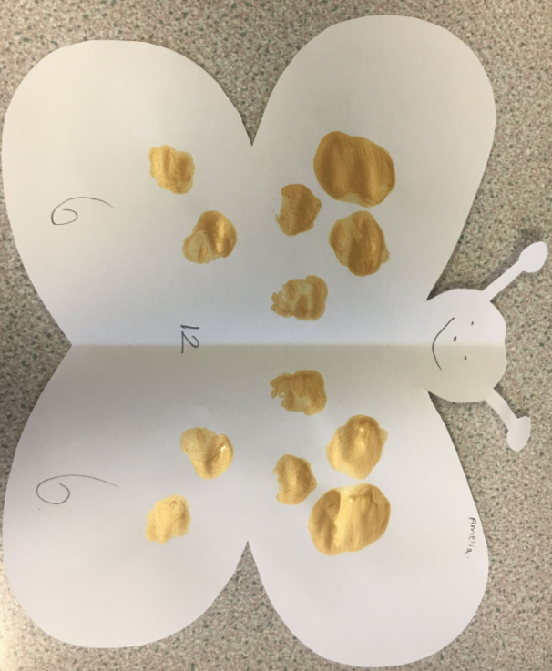 | 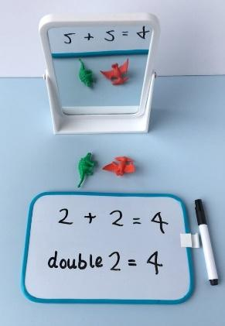

Multiplication - KS1
Stage | Concrete | Pictorial | Abstract
2 | Making equal groups.  It is important for children to see equal groups that are arranged differently, so they understand that groups can look different but still be equal in number. They recognise and explain how they know when there are equal groups and when there are not. To do this, children need to see lots of different examples of equal groups in different contexts.  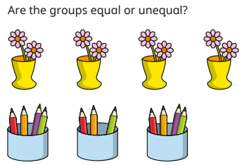  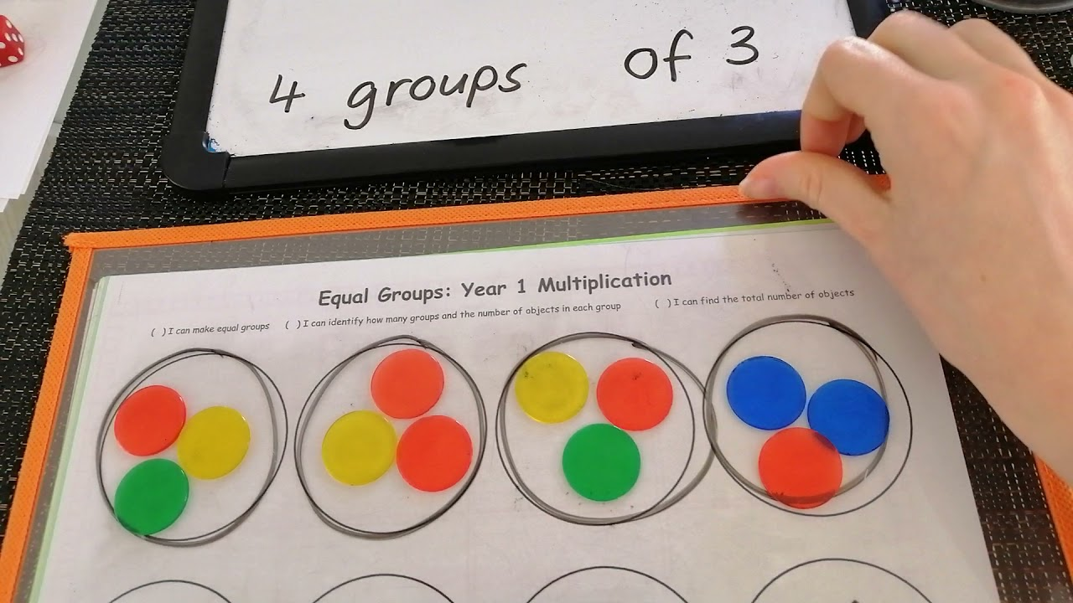 | 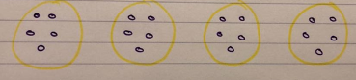 | “____ groups of ____”
3 | Add equal groups (repeated addition).  Children will count groups of the same number of objects and add them together. The children learn about grouping in practical contexts and through pictorial representations. They start by focusing on counting equal groups of 2, 5 and 10 and explore this within 50. Children could begin by linking this to real life, for example animal legs, wheels, flowers in vases etc.    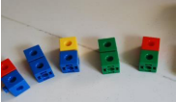  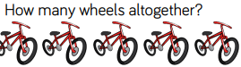 | Children draw representations to show counting in multiples and groups.    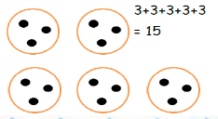  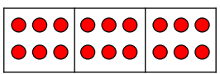  6 + 6 + 6 = 18 | Children show multiplication as repeated addition. Children to write these alongside pictorial representations.  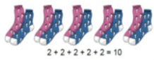  3 + 3 + 3 = 9
5 | Make arrays  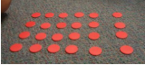  This step focuses on the fact that multiplication is commutative and children should be encouraged to identify the two multiplication sentences that can be seen in an array. Concrete resources should be used to help identify different sets of equal groups. Discuss why an array is a useful and efficient tool to calculate a multiplication and encourage children to draw arrays to represent the multiplication.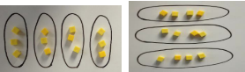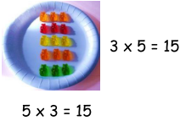 | Children draw representations to show arrays.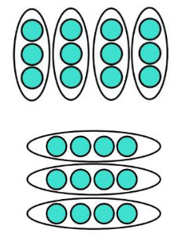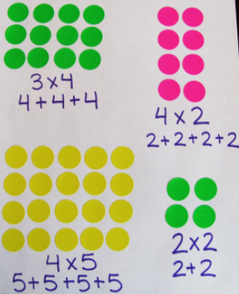 | 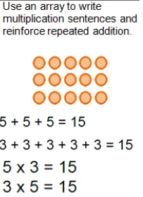  Children use arrays to show how to solve multiplication calculations. Children can show that multiplication can be done in any order (commutative).  3 x 5 = 15 5 x 3 = 15  Introduce x sign and record as  number sentence  7 x 10 = 70  4 x 5 = 20
Multiplication – LKS2
Stage | Concrete | Pictorial | Abstract
6 | Multiply using arrays.  children build and use arrays to enhance their knowledge of the link between repeated addition and multiplication and to explore commutativity. The only examples included refer to the times-table facts that children should know from Year 2, but can be revisited later in the block as children are introduced to more times-table facts.  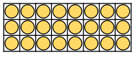  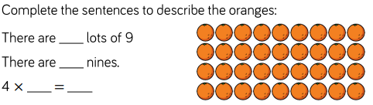  Children to also draw on their knowledge of known times tables to calculate unknown times tables facts.  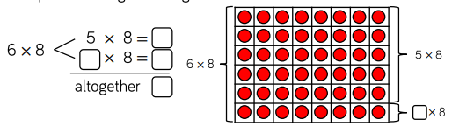 | Children to draw representations to show arrays.  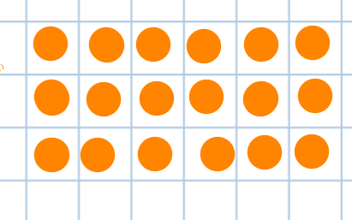 | Children use arrays to show how to solve multiplication calculations. Children can show that multiplication can be done in any order (commutative).
7 | Multiply using partitioning (no exchange).  At this stage, none of the multiplication  calculations require exchanges. Children apply their understanding of partitioning to represent and solve calculations using the expanded method. This is explored through a progression of representations from base 10 to place value counters and part-whole models, alongside number sentences.  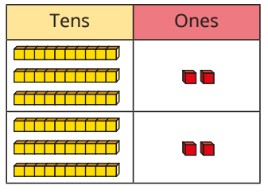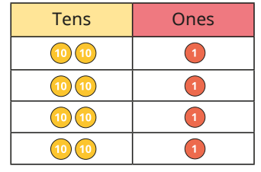 | 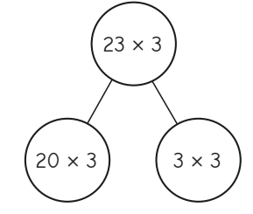 | 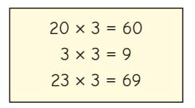  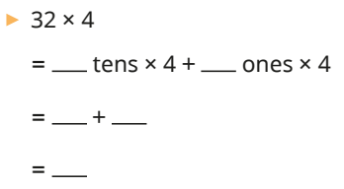
8 | Multiply using partitioning (exchange).  Children continue to explore multiplying 2-digit numbers by 1-digit numbers, now looking at calculations that involve an exchange. This involves partitioning the 2-digit number into tens and ones, multiplying separately, then adding the partial products together. Children use the same representations as in the previous steps to provide familiarity and focus their attention on the new aspect of making an exchange. Use of the expanded method allows children to gain a deep understanding of the structure of the calculation.  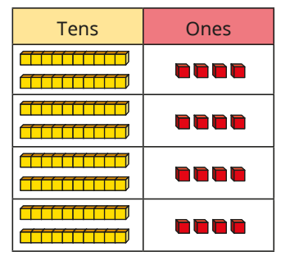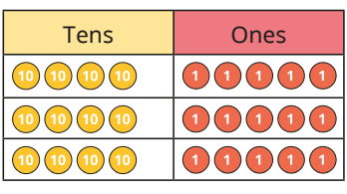 | 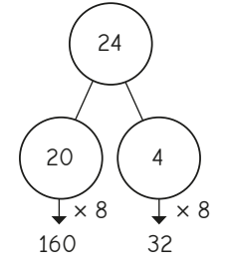 | 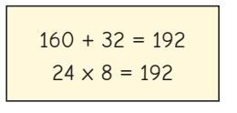  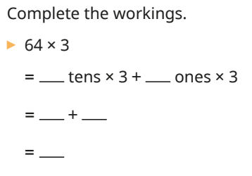
9 | Multiply using the expanded form.  Children progress from multiplying using informal written methods to the formal written method. The short multiplication method is introduced for the first time, initially in an expanded form and then in the formal short single-line form. Children first do calculations where there are no exchanges, then move on to one and two exchanges. Place value counters in place value charts are used to illustrate the structure of the short multiplication by presenting the concrete model alongside the formal written method. Concrete manipulatives alongside abstract calculations are particularly useful to support children’s understanding of exchanges.  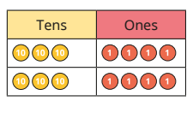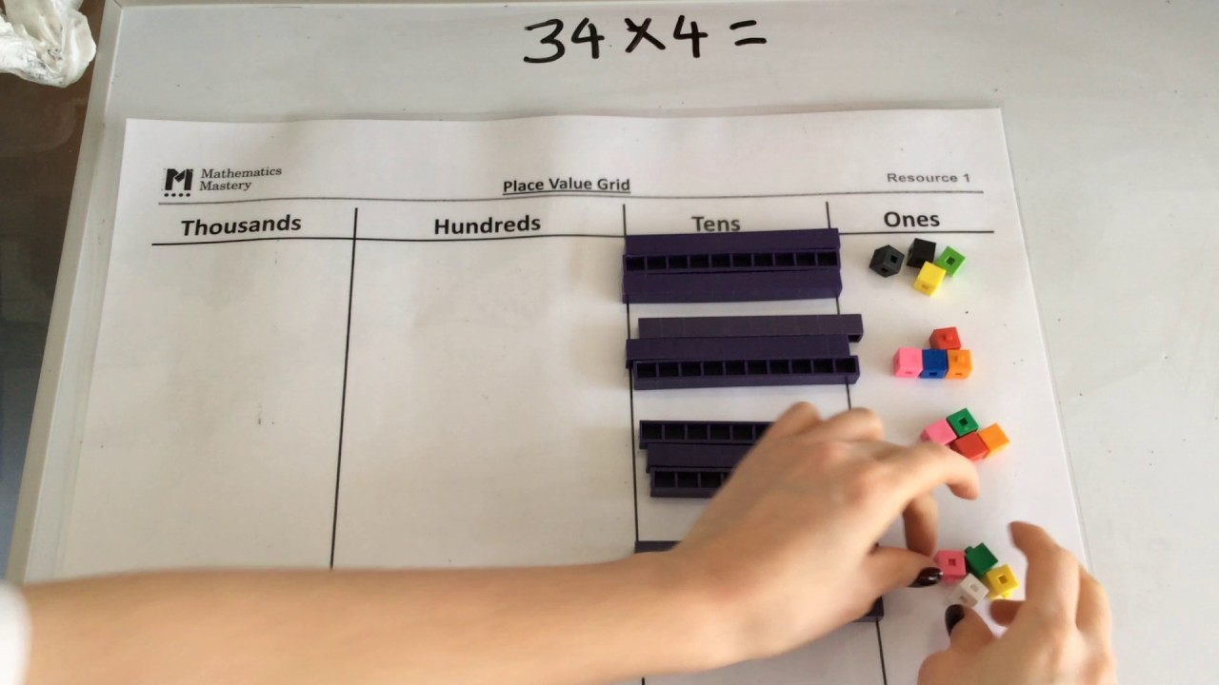 |  | 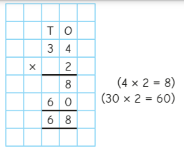
10 | Short multiplication.  They continue to use the short multiplication method, but now with more columns. Children need to be secure with the previous step before moving on to this one. Place value counters in place value charts are again used to model the structure of the formal method, allowing children to gain a greater understanding of the procedure, particularly where exchanges are needed. They continue to use the counters to exchange groups of 10 ones for 1 ten and also exchange 10 tens for 1 hundred and 10 hundreds for 1 thousand. This is mirrored by the positioning of the exchanged digit in the formal written method.  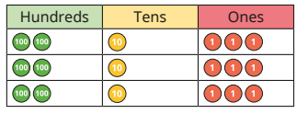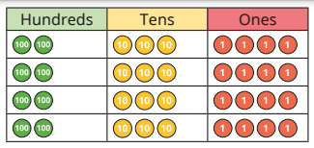 |  | 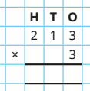  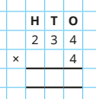
Multiplication – UKS2
Stage | Concrete | Pictorial | Abstract
11 | Short multiplication with larger numbers.  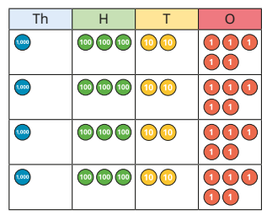This small step builds on this learning and extends the formal written method for short multiplication to multiplying 4-digit numbers by a 1-digit number. Place value counters in place value charts are used to model the structure of the formal method, enabling children to gain a greater understanding of the abstract procedure. Children continue to use counters to exchange groups. |  | 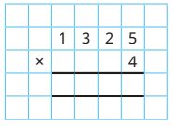
12 | Multiply using the area model.  Children use the area model to multiply a 2-digit number by another 2-digit number. Linking the use of the area model to children’s prior knowledge of arrays helps children to understand the model. They see that to find the total product, they can break the calculation down, find other products and then add them together. Initially, the area model is represented using base 10, which will enable children to understand size, scale and place value. Once the children have a good understanding of place value within the area model, they use place value counters to work more efficiently. They then progress to using only numbers in the model.  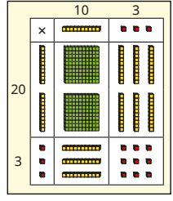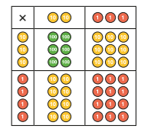 | Pictorial representations can be made using their concrete manipulatives as visuals. They can draw the counters using colours to show different amounts or just use the circles in the different columns to show their thinking as shown.  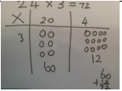 | 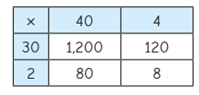  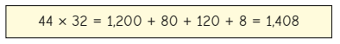
13 | Long multiplication.  children progress from the area model to using the formal written method for multiplication. Encourage children to recognise the links between the area model and the formal method, noting where the subtotals in the formal method match the totals of parts of the area model. This will support children’s understanding of each step of the calculation process.  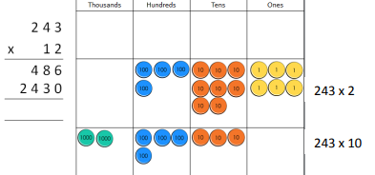 |  | 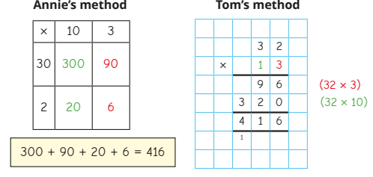
14 | Multiplying decimals.  Children look at related multiplication facts using concrete resources such as place value counters, exploring relationships. They then multiply numbers with up to 2 decimal places by 1-digit integers using rows of place value counters, exchanging when needed.  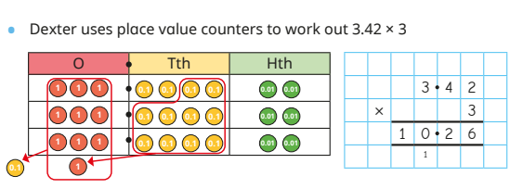  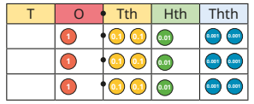 | 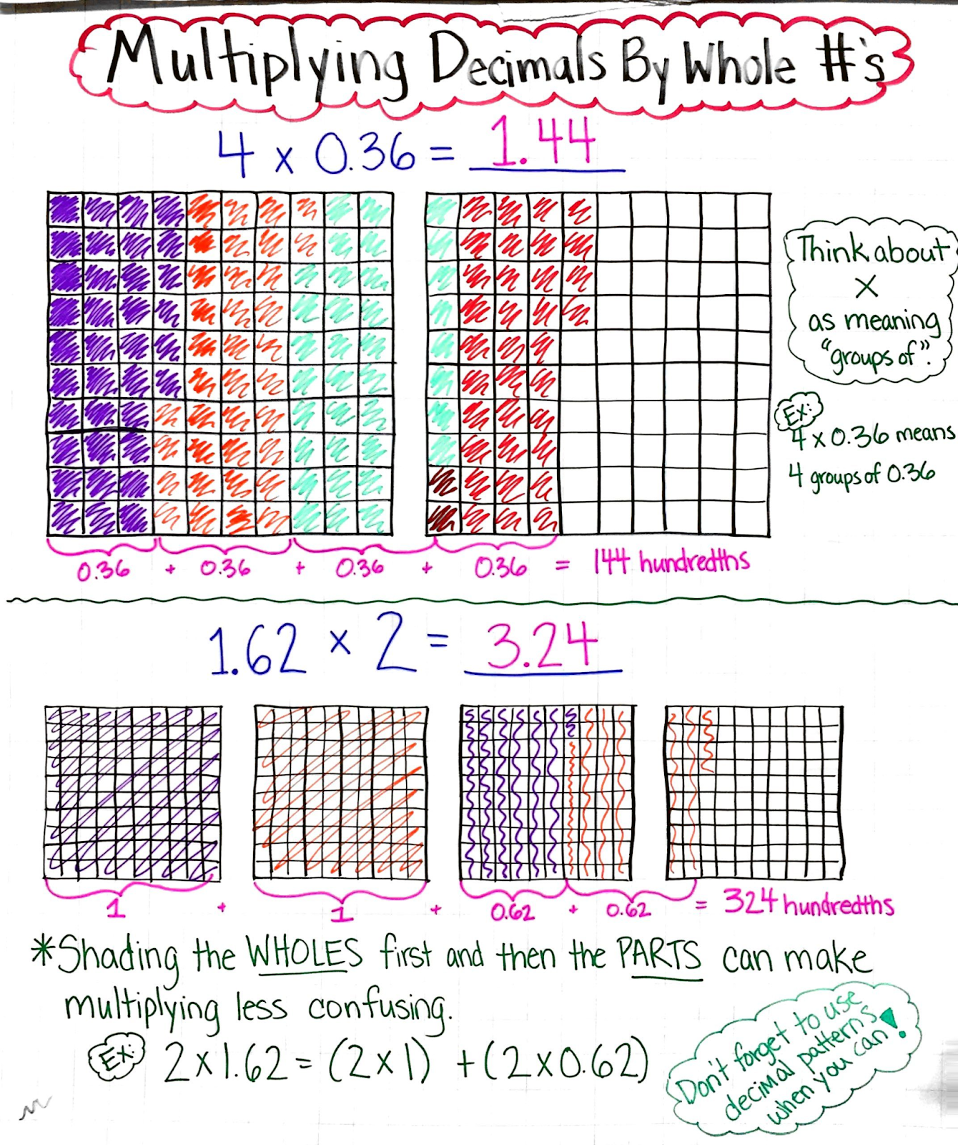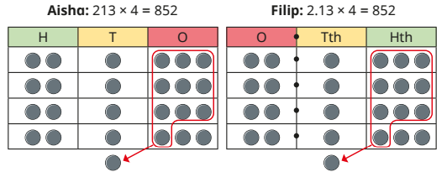 | 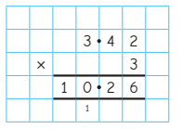  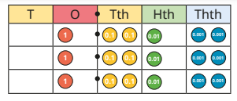

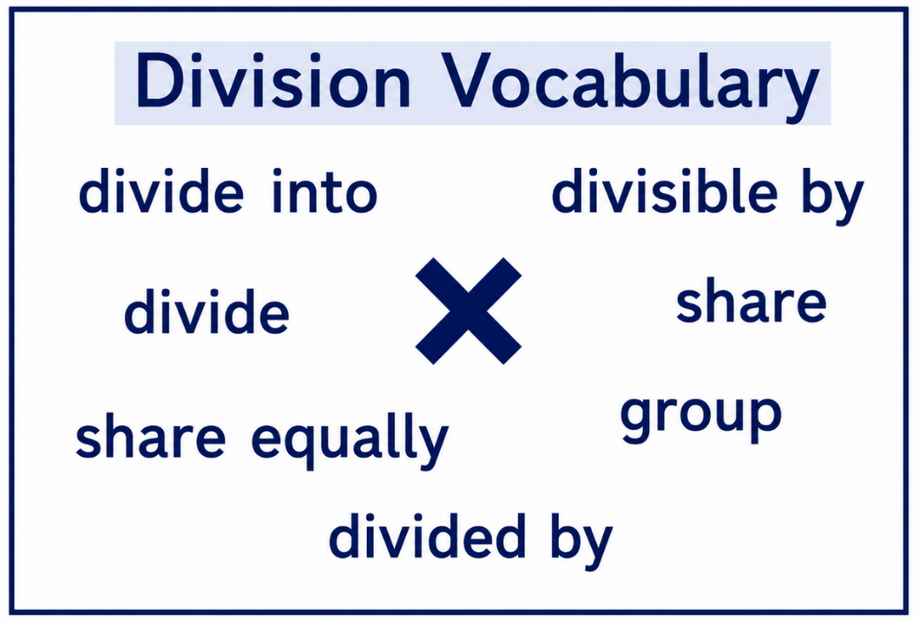
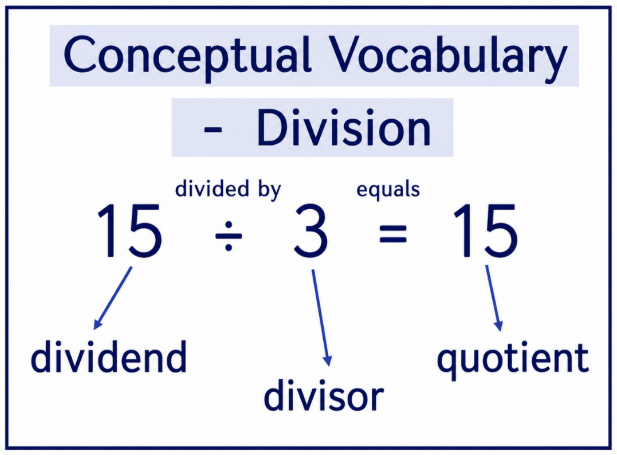

Division - EYFS
Stage | Concrete | Pictorial | Abstract
1 | Sharing fairly  The children will probably already have some experience of sharing and will be quick to point out when items are not shared fairly. During snack time or group activities, encourage them to check that the items are shared equally and that everyone has the  same. Provide opportunities of real-life contexts to show sharing fairly. They could share out the cards or dominoes before playing a game. Prompt the children to notice that sometimes they can make equal groups and sometimes they have items left over.  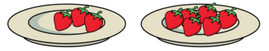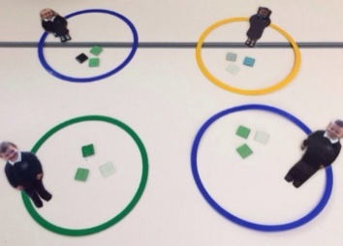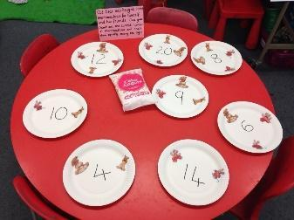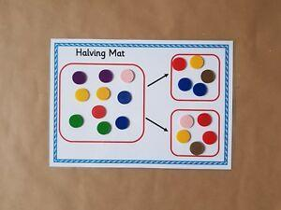
2 | Sorting into equal groups.  The children should also be given opportunities to recognise and make equal groups. Can they give each gingerbread man 3 buttons? Can they give each child 5 carrot sticks during snack? Can they arrange their pebbles into groups of 2? What about groups of 3?  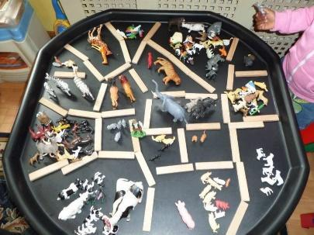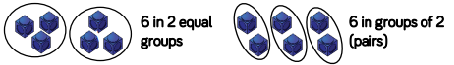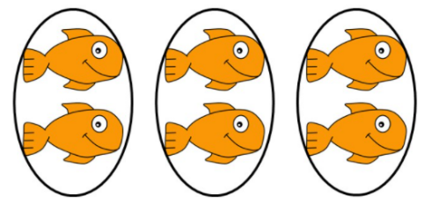

Division - KS1
Stage | Concrete | Pictorial | Abstract
3 | Sharing objects equally.  Divide quantities by sharing into equal groups. Use range of objects including cubes, counters, objects, or place value counters to aid understanding.  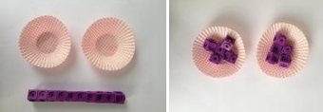  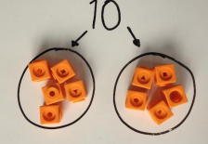  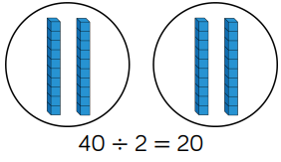 | Use pictures to share objects. Use circles rather than dots to aid counting.  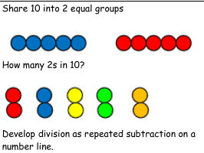  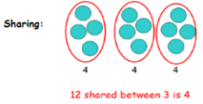  Children to also start sharing using a bar model.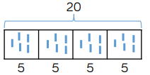 | Children will be able to represent a division calculation using a pictorial method and write the division within a number sentence using the divide symbol.
4 | Making equal groups.  Divide quantities into equal groups. Use range of objects including cubes, counters, objects or place value counters to aid understanding.  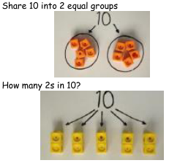 | Children to draw circles around objects and pictures to show grouping.  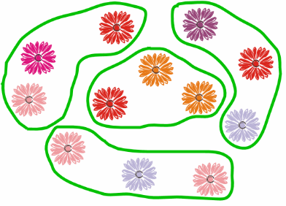  Children will also a number line to work out how many equal groups there are.  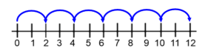 | Children to develop an understanding that 10 ÷ 2 = 5 can be 10 divided into 2 groups or 10 divided into groups of 2.
5 | Link multiplication and division.  Link division to multiplication by  creating an array using manipulatives and thinking about the number sentences that can be created.  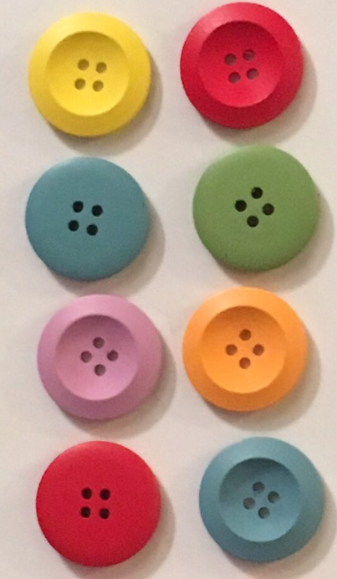 | Draw an array and use lines to split the  array into groups to make multiplication  and division sentences: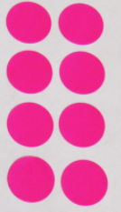 | Find the inverse of multiplication and  division sentences by creating eight linking number sentences.  8 ÷ 2 = 4 2 x 4 = 8  8 ÷ 4 = 2 4 x 2 = 8  4 = 8 ÷ 2 8 = 2 x 4  2 = 8 ÷ 4 8 = 4 x 2
Division – LKS2
Stage | Concrete | Pictorial | Abstract
6 | Divide using partitioning (no exchange).  Children build on their knowledge of times-tables and division facts, using these to support them when dividing a 2-digit number by a 1-digit number. This step focuses on partitioning a number into tens and ones and sharing into equal groups, dividing numbers that do not involve exchanging or remainders. Place value counters are used to support their understanding.  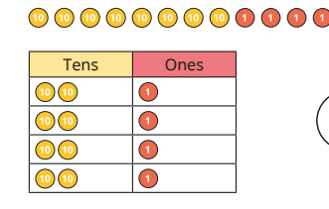 | Children use part-whole models to represent the calculations and support their understanding. It is important that children divide the tens first and then the ones.  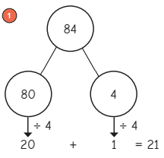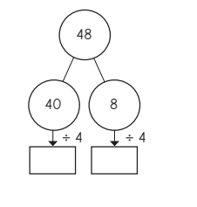 | 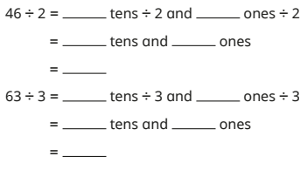
7 | Division using partitioning (exchange).  They now begin to look at calculations that involve exchanging between the tens and the ones. Children can use place value counters to support their understanding and part-whole models to show what calculations have been done.  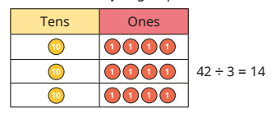  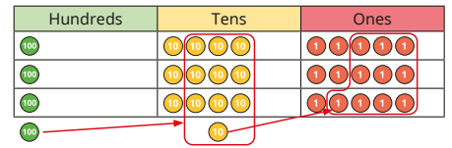 | 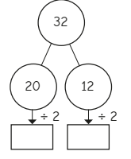  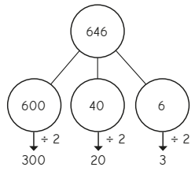 | 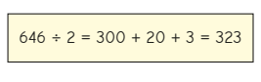
Division – UKS2
Stage | Concrete | Pictorial | Abstract
8 | Short division (no exchange).  Building on informal methods used in Years 3 and 4, this small step introduces children to the formal written method of short division. Place value counters are used to support the children.  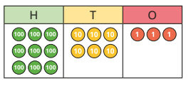  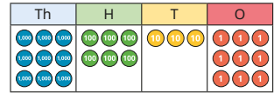 | The formal calculation is shown alongside familiar models, in particular part-whole models and place value charts. In this way, the structure of short division becomes clear, enabling children to see the relationship between the model and the formal written method.  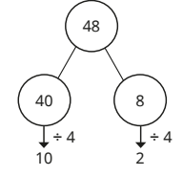 | 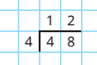  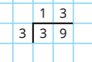  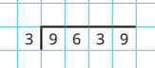
9 | Short division (exchange).  Place value counters continue to be used to represent the calculations alongside the formal written method, so that children can visualise how one relates to the other. In particular, place value counters in place value charts help children to make sense of the steps that they are taking and how this relates to the context of the question.  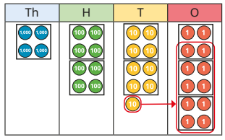 | Students continue to use drawn diagrams with circles to help them divide numbers into equal groups. Remainders will be seen by not fitting into a whole group.  Children can use jottings and dots to divide numbers however this can become inefficient if there are more than 2 counters being exchanged. Children to draw on their times table knowledge instead in this case. | Children continue to build their understanding of short division, by dividing larger numbers by 1 and 2-digits.  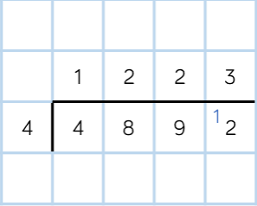  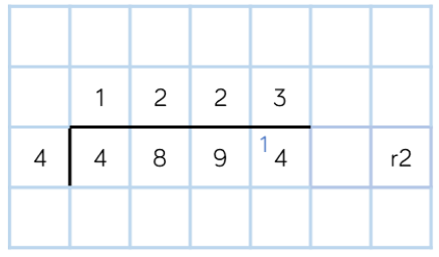
10 | Short division (2-digit numbers). |  | Children will be encouraged to write multiples of the divisor (number they’re dividing by) using the partitioning method to support their calculations.  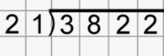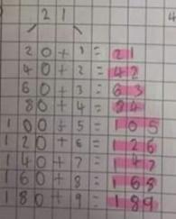
11 | Long division  Children divide 3-digit numbers without remainders, using an expanded method that shows the multiples, before progressing to a more formal long division method. They divide 4-digit numbers, still without remainders, using their knowledge of multiplying by 10 and 100. When dividing by composite numbers, it may be worth comparing the long division method with the method of division using factors covered in the previous small step.  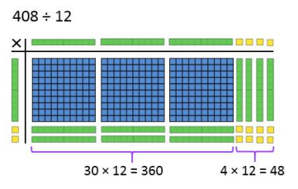  https://www.youtube.com/watch?v=vwgLPLd181k |  | 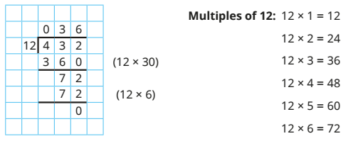  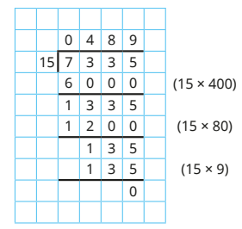
12 | Division with decimals.  Children explore a range of division facts using times-table knowledge, for example 144 ÷ 12 = 12, so 1.44 ÷ 12 = 0.12. Using place value counters, children put counters into groups, starting with the greatest place value column. They start with division where no exchanges are needed before moving on to calculations needing exchanges. They use the formal written method for division alongside the place value charts.  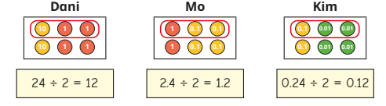  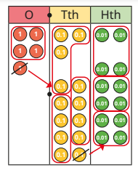 | Students continue to use drawn diagrams with circles to help them divide numbers into equal groups. | 