North Bradley C.E. Primary School

Modern Foreign Languages (MFL) Policy
Introduction

Learning a foreign language is part of the primary National Curriculum and is a requirement for all children within Key Stage 2. North Bradley’s scheme of work uses resources from Language Angels to teach Spanish to all pupils in Key Stage 2.

Intent

At North Bradley, we want to ensure our children receive a relevant, broad, vibrant and ambitious foreign languages curriculum that will inspire and excite our pupils through a wide variety of topics and themes. We also aim for our language programme to offer pupils the opportunity to develop a deepening understanding of other cultures and the world around them. Our intent is that all pupils will develop a genuine interest and positive curiosity about foreign languages, finding them enjoyable and stimulating, to ensure that they become life-long language learners. All pupils are expected to reach their full potential by encouraging high expectations and excellent standards in language learning whilst nurturing the confidence of our language learners.

We use Language Angels to ensure that our curriculum coverage has the breadth and depth that will ensure children have a good foundation for language learning beyond Key Stage 2. Our language learning programme ensures children regularly practise all four language learning skills: listening, speaking, reading and writing. In addition, children will develop their knowledge of grammar from year 3 to year 6 to ensure progression in all four areas so that they can understand more complex language and communicate more effectively. The topics chosen for our year groups ensure that this progression in grammar and language skills occurs but also has a mixture of topics that will enthuse children and provide them with real life, practical contexts in which to practise their language skills.

Teaching and Learning Overview

Our whole school approach to language teaching and learning is in line with the recommendations of the National Curriculum and the requirements outlined in the Department for Education Languages Programme of Study for Key Stage 2.

The National Curriculum for languages aims to ensure that all pupils:

- Understand and respond to spoken and written language from a variety of authentic sources
- Speak with increasing confidence, fluency and spontaneity, finding ways of communicating what they want to say, including through discussion and asking questions, and continually improving the accuracy of their pronunciation and intonation
- Can write at varying length, for different purposes and audiences, using the variety of grammatical structures that they have learnt
- Discover and develop an appreciation of a range of authentic writing in the language studied.

By the end of key stage 2, pupils should be able to:
- Listen attentively to spoken language and show understanding by joining in and responding.
- Explore the patterns and sounds of language through songs and rhymes and link the spelling, sound and meaning of words.
- Engage in conversations; ask and answer questions; express opinions and respond to those of others; seek clarification and help.
- Speak in sentences, using familiar vocabulary, phrases and basic language structures.
- Develop accurate pronunciation and intonation so that others understand when they are reading aloud or using familiar words and phrases.
- Present ideas and information orally to a range of audiences.
- Read carefully and show understanding of words, phrases and simple writing.
- Appreciate stories, songs, poems and rhymes in the language.
- Broaden their vocabulary and develop their ability to understand new words that are introduced into familiar written material, including through using a dictionary.
- Write phrases from memory, and adapt these to create new sentences, to express ideas clearly.
- Describe people, places, things and actions orally and in writing.
- Understand basic grammar appropriate to the language being studied, including (where relevant): feminine, masculine and neuter forms and the conjugation of high-frequency verbs; key features and patterns of the language; how to apply these, for instance, to build sentences; and how these differ from or are similar to English.

Organisation and Delivery

Spanish is taught in a whole-class setting by the class teacher or language lead, depending on the strengths of individual teachers. Teachers plan their lesson using the Language Angels scheme of work and can supplement this with their own ideas and experiences and those of their colleagues. Language lessons occur weekly in each classroom. Each class has a timetabled lesson of at least thirty minutes per week, although it is recognised that some lessons may need to be longer depending on the content of the lesson. In addition, Spanish content can also be revisited in short sessions throughout the week to consolidate knowledge and ensure new language is retained.

The lessons are designed to motivate, captivate and interest children from the first moment. They have clear, achievable objectives and incorporate different learning styles. SEN children have access to the curriculum through resources to scaffold the activity and/or extra adult support, where appropriate. Children are provided with further challenge to extend their learning and apply it independently to different contexts to further challenge those who find language learning easier.

A Typical Spanish Lesson at North Bradley includes:

- A starter to revisit and consolidate previous language taught.
- A PowerPoint or interactive whiteboard materials to introduce and consolidate new language.
- Interactive games on the whiteboard / physical games / flashcard activities to ensure repetition of language to truly embed it.
- Rhymes, songs, stories and poems feature regularly within language lessons, although may not be in all. These might be in the form of a starter or to consolidate new language introduced in that lesson.
- Each element will focus on a combination of the five key language learning skills of speaking, listening, reading, writing and grammar.
- Independent activities to be completed at their tables. This might be a reading, listening, writing or speaking task and include scaffolding and extra challenge to ensure that all children can access and are challenged within the lesson. Worksheets or work in books occurs in at least half of the lessons and should include the date (written in Spanish) and the learning objective (from the scheme of work provided).
- A plenary to revisit and consolidate the language from that lesson.

Our Curriculum at North Bradley
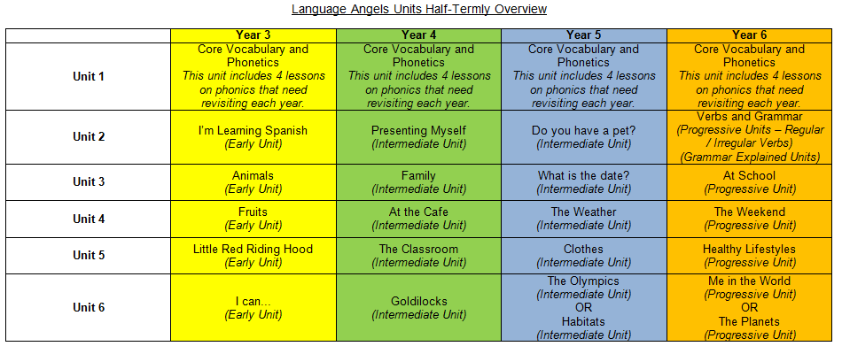
Each Unit is broken down into six lessons (five teaching, one assessment) for the class teacher or language specialist to deliver. This includes the main learning objective for that lesson and notes possibilities for additional assessment of listening and reading skills to ensure that these remain as prevalent in our curriculum as speaking and writing tasks.
Resources
The Language Angels scheme is a fully online resource enabling all teachers in all classes to have instant and continuous access to allthe resources they need to teach whichever lesson they choose. It is expected that teachers pull from this and other sources of their choice, adapting any activities to ensure that all books and lessons are consistent and meet the learning objectives.
Other useful resources that teachers may use as and when appropriate are:
- https://rockalingua.com/ – this website provides videos, worksheets, songs, games and picture dictionaries organised by themes. It is most useful for providing opportunities to use songs to embed language covered in class.
- Physical books – Spanish stories, poems and tongue twister books are available within school to use to support a broad and varied experience of language within the classroom.
- Spanish Dictionaries – are also provided within the school.
Evidence of Teaching & Learning and Transition at End of Key Stage
Children complete worksheets in their books, which continue throughout the years. This is a portfolio of their learning to show progression within each unit, year and across the Key Stage, as well as the coverage of each unit and language skill. The Subject Leader also collects photocopies of a selection of children’s work from each unit in each year group to monitor and ensure progression. Furthermore, teachers can record learning in speaking and listening skills by uploading video or audio clips onto the server or by using QR codes to display in pupil’s language books or the class floor book. Teachers provide copies of their assessment to the language lead to ensure constant revision of the scheme of work and teaching to ensure progression.

At the end of Key Stage Two, information about the pupil’s individual knowledge and skills can be forwarded to their secondary school as part of the transition process.
Assessment of Pupil Learning & Progression
It is our aim that assessment is a seamless part of the language learning process and is used to ensure that all children make progress within each lesson. Children are assessed in different ways throughout the course of a unit of work:
Children regularly complete work in their books as part of the lesson. This is assessed against the learning objective and supports teachers in ensuring all children make progress in each and every lesson.
Within the Language Unit scheme of work provided by the language lead, there are specific opportunities for additional listening and reading assessments that class teachers are expected to use with their class as part of the lesson to ensure breadth of assessment is not just focusing on speaking and writing skills.
At the end of each unit, children complete an assessment activity that has 5 tasks per strand of language skills (reading, writing, listening, speaking) to ensure that children are assessed across all 4 strands.
At the end of each unit, the teacher delivering the language learning makes an assessment of above, expected and below for each pupil in the class.
Monitoring and evaluation
The Subject Leader monitors the effectiveness of the language teaching provided throughout the school via regular observations with feedback given to teachers delivering foreign language lessons. In addition, the Subject Leader and class teacher will together monitor the learning and progression made by pupils within each year group and all assessment data is shared between both. This data will be stored securely by the class teacher and Subject Leadership and will also be used to inform parent-teacher meetings and reports, as well as being used to monitor the effectiveness of the scheme of work.
The Subject Leader will also aim to raise the profile of Spanish within the school, through the encouragement of Spanish displays and for Spanish to be featured within celebration assemblies and showcases, where appropriate.

Policy reviewed – September 2020.
Review date – September 2022.

